**BUSA8090 - Data and Visualisation for Business**

**Assignment 1**

**Urban Eats Café Chain: Analytics and Database Design Report**

**Student Name: Muntasir Md Nafis**

**Student ID: 48312932**

# Part A – Database Design and Development

## Entity Identification

|  |  |
| --- | --- |
| **Entity Name** | **Entity Description** |
| Outlet | List of store locations with their name, address, phone, and email. |
| Customer | Registered customers with names and contact details (plus optional address) used to tie reservations and orders. |
| Product_Category | List of product categories with their names and short descriptions. |
| Product | |  | | --- | |  |  |  | | --- | | Individual menu items with price, linked to a product category for analysis and availability. | |
| Shift | Scheduled work periods per outlet with start/end times and maximum staffing capacity. |
| Reservation | Customer bookings at outlets capturing date/time, number of people and reservation status. |
| Orders | Customer purchases at outlets with order date, type (dine-in/takeaway/delivery) and current status. |
| Payment | Financial records for each order including amount, method and payment status. |
| Staff | Employee directory with role/designation, employment status, manager hierarchy and outlet assignment. |
| Outlet_Product | Mapping of which products are available or unavailable at each outlet. |
| Order_Product | Links each order to its products with quantity and price. |
| Staff_Shift | Assignment of staff to specific shifts with role performed and hours worked. |

## Identify Attributes, Primary Keys and Foreign Keys

|  |  |
| --- | --- |
| **Entity Name** | **Attributes** |
| OUTLET | Outlet_ID **(PK)**, Outlet_Name, Address, Phone, Email |
| CUSTOMER | Customer_ID **(PK)**, First_Name, Last_Name, Email, Contact, Customer_Address |
| PRODUCT_CATEGORY | Product_Category_ID **(PK)**, Product_Category_Name, Product_Category_Description |
| PRODUCT | Product_ID **(PK)**, Product_Name, Price, Category_ID **(FK → Product_Category.Product_Category_ID)** |
| SHIFT | Shift_ID **(PK)**, Outlet_ID **(FK → Outlet.Outlet_ID)**, Start_Time, End_Time, Max_Staff |
| RESERVATION | Reservation_ID **(PK)**, Outlet_ID **(FK → Outlet.Outlet_ID)**, Customer_ID **(FK → Customer.Customer_ID)**, Date, Time, Number_of_People, Status |
| ORDERS | Order_ID **(PK)**, Outlet_ID **(FK → Outlet.Outlet_ID)**, Customer_ID **(FK → Customer.Customer_ID)**, Order_Date, Order_Type, Order_Status |
| PAYMENT | |  | | --- | |  |  |  | | --- | | Payment_ID **(PK)**, Order_ID **(FK → Orders.Order_ID)**, Payment_Amount, Payment_Method, Payment_Status | |
| STAFF | Staff_ID **(PK)**, First_Name, Last_Name, Designation, Employment_Status, Manager_ID **(FK → Staff.Staff_ID)**, Outlet_ID **(FK → Outlet.Outlet_ID)** |
| OUTLET-PRODUCT | Product_ID **(PK, FK → Product.Product_ID)**, Outlet_ID **(PK, FK → Outlet.Outlet_ID)**, Outlet_Status |
| ORDER-PRODUCT | Order_ID **(PK, FK → Orders.Order_ID)**, Product_ID **(PK, FK → Product.Product_ID)**, Quantity, Price |
| STAFF-SHIFT | Staff_ID **(PK, FK → Staff.Staff_ID)**, Shift_ID **(PK, FK → Shift.Shift_ID)**, Staff_Role, Working_Hours |

## Relationship Definition and Cardinality Analysis

The relationship between Outlet and Order is one-to-many, as each outlet can have many orders while every order belongs to exactly one outlet. Similarly, the relationship between Customer and Order is also one-to-many, because a customer can place multiple orders, but each order is tied to a single customer. Between Order and Payment, the relationship is one-to-many since an order may generate multiple payment records (including partial payments, refunds, or failures), but each payment refers to only one order.

For Reservations, the link to both Outlet and Customer is one-to-many. An outlet can host many reservations and a customer can book multiple reservations, but each reservation record belongs to one outlet and one customer only.

The Product and Product_Category entities are in a one-to-many relationship, with each category containing many products, while each product belongs to exactly one category. To capture order details, the Orders and Products relationship is implemented through Order_Product(associative entity), which creates a many-to-many relationship. An order can contain multiple products, and a product can appear in many different orders.

The availability of menu items across locations is handled by Outlet_Product(associative entity), which establishes a many-to-many relationship between outlets and products. Each outlet may list several products, and each product can be offered in multiple outlets.

In staffing, the relationship between Outlet and Shift is one-to-many, as an outlet schedules multiple shifts, but each shift belongs to one outlet. The Staff_Shift(associative entity) table defines a many-to-many relationship between staff and shifts, where staff members can cover multiple shifts, and each shift can include multiple staff members. Additionally, within the Staff table, there is a one-to-many uniary relationship: one staff member can act as a manager for many others, but each staff member has at most one direct manager.

## ERD diagram

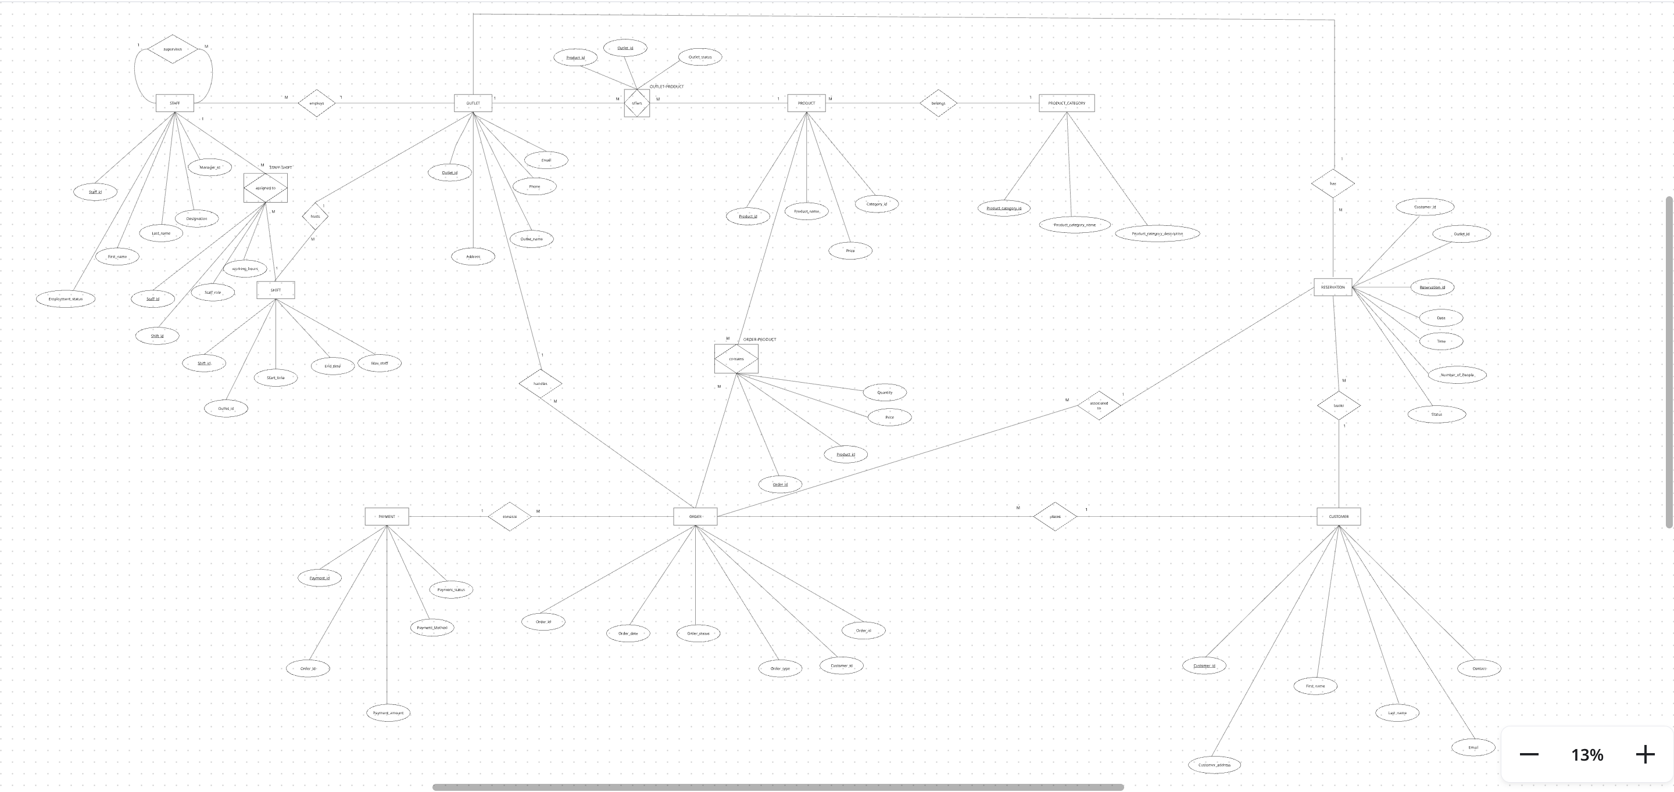

## Table implementation

# Creating OUTLET Table

CREATE TABLE Outlet (

Outlet_ID INT PRIMARY KEY,

Outlet_Name VARCHAR(100) NOT NULL,

Address VARCHAR(200) NOT NULL,

Phone VARCHAR(20),

Email VARCHAR(120)

);

# Creating CUSTOMER Table

CREATE TABLE Customer (

Customer_ID INT PRIMARY KEY,

First_Name VARCHAR(60) NOT NULL,

Last_Name VARCHAR(60) NOT NULL,

Email VARCHAR(120),

Contact VARCHAR(20)

);

ALTER TABLE Customer

ADD Customer_Address VARCHAR(200);

# Creating PRODUCT_CATEGORY Table

CREATE TABLE Product_Category (

Product_Category_ID INT PRIMARY KEY,

Product_Category_Name VARCHAR(100) NOT NULL,

Product_Category_Description VARCHAR(255)

);

# Creating PRODUCT Table

CREATE TABLE Product (

Product_ID INT PRIMARY KEY,

Product_Name VARCHAR(120) NOT NULL,

Price DECIMAL(10,2) NOT NULL,

Category_ID INT NOT NULL,

FOREIGN KEY (Category_ID) REFERENCES Product_Category(Product_Category_ID)

);

# Creating SHIFT Table

CREATE TABLE Shift (

Shift_ID INT PRIMARY KEY,

Outlet_ID INT NOT NULL,

Start_Time TIME NOT NULL,

End_Time TIME NOT NULL,

Max_Staff INT NOT NULL,

FOREIGN KEY (Outlet_ID) REFERENCES Outlet(Outlet_ID)

);

# Creating RESERVATION Table

CREATE TABLE Reservation (

Reservation_ID INT PRIMARY KEY,

Outlet_ID INT NOT NULL,

Customer_ID INT NOT NULL,

Date DATE NOT NULL,

Time TIME NOT NULL,

Number_of_People INT NOT NULL,

Status VARCHAR(20),

FOREIGN KEY (Outlet_ID) REFERENCES Outlet(Outlet_ID),

FOREIGN KEY (Customer_ID) REFERENCES Customer(Customer_ID)

);

# Creating ORDER Table

CREATE TABLE Orders (

Order_ID INT PRIMARY KEY,

Outlet_ID INT NOT NULL,

Customer_ID INT NOT NULL,

Order_Date DATE NOT NULL,

Order_Type VARCHAR(20) NOT NULL,

Order_Status VARCHAR(20) NOT NULL,

FOREIGN KEY (Outlet_ID) REFERENCES Outlet(Outlet_ID),

FOREIGN KEY (Customer_ID) REFERENCES Customer(Customer_ID)

);

# Creating PAYMENT Table

CREATE TABLE Payment (

Payment_ID INT PRIMARY KEY,

Order_ID INT NOT NULL,

Payment_Amount DECIMAL(10,2) NOT NULL,

Payment_Method VARCHAR(20),

Payment_Status VARCHAR(20),

FOREIGN KEY (Order_ID) REFERENCES Orders(Order_ID)

);

# Creating STAFF Table

CREATE TABLE Staff (

Staff_ID INT PRIMARY KEY,

First_Name VARCHAR(60) NOT NULL,

Last_Name VARCHAR(60) NOT NULL,

Designation VARCHAR(50) NOT NULL,

Employment_Status VARCHAR(20) NOT NULL,

Manager_ID INT ,

Outlet_ID INT NOT NULL,

FOREIGN KEY (Outlet_ID) REFERENCES Outlet(Outlet_ID),

FOREIGN KEY (Manager_ID) REFERENCES Staff(Staff_ID)

);

# Creating OUTLET-PRODUCT Table

CREATE TABLE Outlet_Product (

Product_ID INT NOT NULL,

Outlet_ID INT NOT NULL,

Outlet_Status VARCHAR(20),

PRIMARY KEY (Product_ID, Outlet_ID),

FOREIGN KEY (Product_ID) REFERENCES Product(Product_ID),

FOREIGN KEY (Outlet_ID) REFERENCES Outlet(Outlet_ID)

);

# Creating ORDER-PRODUCT Table

CREATE TABLE Order_Product (

Order_ID INT NOT NULL,

Product_ID INT NOT NULL,

Quantity INT NOT NULL,

Price DECIMAL(10,2) NOT NULL,

PRIMARY KEY (Order_ID, Product_ID),

FOREIGN KEY (Order_ID) REFERENCES Orders(Order_ID),

FOREIGN KEY (Product_ID) REFERENCES Product(Product_ID)

);

# Creating STAFF-SHIFT Table

CREATE TABLE Staff_Shift (

Staff_ID INT NOT NULL,

Shift_ID INT NOT NULL,

Staff_Role VARCHAR(40),

Working_Hours DECIMAL(5,2),

PRIMARY KEY (Staff_ID, Shift_ID),

FOREIGN KEY (Staff_ID) REFERENCES Staff(Staff_ID),

FOREIGN KEY (Shift_ID) REFERENCES Shift(Shift_ID)

);

## Dummy Data insertion

# Inserting Dummy Data into OUTLET Table

INSERT INTO Outlet (Outlet_ID, Outlet_Name, Address, Phone, Email) VALUES

(1, 'Urban Eats Central', '100 George St, Sydney NSW 2000', '02 8000 1001', 'central@urbaneats.com.au'),

(2, 'Urban Eats Harbour', '22 Wharf Rd, Sydney NSW 2000', '02 8000 1002', 'harbour@urbaneats.com.au'),

(3, 'Urban Eats Campus', '15 University Ave, Macquarie NSW 2109', '02 8000 1003', 'campus@urbaneats.com.au');

# Inserting Dummy Data into CUSTOMER Table

INSERT INTO Customer (Customer_ID, First_Name, Last_Name, Email, Contact) VALUES

(101, 'Ava', 'Brown', 'ava.brown@gmail.com', '0411 234 567'), -- Central repeater + reservation (Challenges Associated)

(102, 'Liam', 'Ng', 'liam.ng@outlook.com', '0412 345 678'), -- one-timer (at risk)

(103, 'Noah', 'Khan', 'noah.khan@gmail.com', '0413 456 789'), -- Harbour delivery loyalist

(104, 'Mia', 'Chen', 'mia.chen@proton.me', '0414 567 890'), -- Harbour dine-in + reservation

(105, 'Olivia', 'Taylor', 'olivia.taylor@gmail.com', '0415 678 901'), -- Campus no-show risk

(106, 'Lucas', 'White', 'lucas.white@outlook.com', '0416 789 012'), -- Central takeaway repeater

(107, 'Grace', 'Park', 'grace.park@gmail.com', '0417 890 123'), -- Central occasional (desserts)

(108, 'Ethan', 'Rao', 'ethan.rao@gmail.com', '0418 901 234'), -- Harbour cold-drinks fan

(109, 'Sofia', 'Gonzalez', 'sofia.gonzalez@outlook.com', '0419 012 345'), -- Campus student; low frequency

(110, 'Arjun', 'Singh', 'arjun.singh@gmail.com', '0420 123 456'), -- Central repeater (coffee)

(111, 'Zara', 'Haddad', 'zara.haddad@gmail.com', '0421 234 567'), -- Harbour dessert buyer

(112, 'Ben', 'Wilson', 'ben.wilson@company.com', '0422 345 678'), -- delivery-only occasional

(113, 'Isabella','Lopez', 'isabella.lopez@gmail.com', '0423 111 111'), -- Central brunch group; repeat

(114, 'Jack', 'O’Connor', 'jack.oconnor@outlook.com', '0424 222 222'), -- one-time Harbour tourist

(115, 'Yuki', 'Tanaka', 'yuki.tanaka@gmail.com', '0425 333 333'), -- student at Campus; cheap orders

(116, 'Carlos', 'Martinez', 'carlos.martinez@gmail.com', '0426 444 444'), -- Harbour; repeat desserts

(117, 'Amira', 'Ali', 'amira.ali@outlook.com', '0427 555 555'), -- Central; reservation & repeat

(118, 'Daniel', 'Green', 'dan.green@gmail.com', '0428 666 666'), -- Harbour; cold drinks only

(119, 'Priya', 'Sharma', 'priya.sharma@gmail.com', '0429 777 777'), -- Central; takeaway loyalist

(120, 'Mohammed','Saleh', 'm.saleh@company.com', '0430 888 888'), -- delivery only; mixed outlets

(121, 'Ella', 'Nguyen', 'ella.nguyen@gmail.com', '0431 999 999'), -- Campus; rarely orders

(122, 'George', 'Patel', 'george.patel@outlook.com', '0432 101 010'), -- Central; high-value family orders

(123, 'Chloe', 'Anderson', 'chloe.anderson@gmail.com', '0433 202 020'), -- Harbour + reservations

(124, 'Mateo', 'Silva', 'mateo.silva@gmail.com', '0434 303 030'), -- Central coffee repeat

(125, 'Hannah', 'Kim', 'hannah.kim@outlook.com', '0435 404 040'), -- Harbour; churn risk

(126, 'Oliver', 'Wright', 'oliver.wright@gmail.com', '0436 505 050'), -- Central; repeat latte buyer

(127, 'Emily', 'Davis', 'emily.davis@gmail.com', '0437 606 060'), -- Campus; only 1 order

(128, 'Jacob', 'Foster', 'jacob.foster@company.com', '0438 707 070'), -- Central + Harbour orders

(129, 'Sara', 'Hassan', 'sara.hassan@gmail.com', '0439 808 080'), -- Harbour; loyal customer

(130, 'Leo', 'Baker', 'leo.baker@gmail.com', '0440 909 090'); -- Central + delivery

# Inserting Dummy Data into PRODUCT_CATEGORY Table

INSERT INTO Product_Category (Product_Category_ID, Product_Category_Name, Product_Category_Description) VALUES

(1, 'Espresso Classics', 'Short black, long black, doppio'),

(2, 'Milk Coffees', 'Latte, cappuccino, flat white'),

(3, 'Specialty Coffees', 'Mocha and flavoured coffee drinks'),

(4, 'Teas', 'Black, green, chai, herbal'),

(5, 'Hot Chocolate', 'Cocoa-based hot drinks'),

(6, 'Iced Coffees', 'Iced latte, iced mocha'),

(7, 'Cold Brew', 'Slow-brewed chilled coffees'),

(8, 'Smoothies', 'Fruit and yoghurt smoothies'),

(9, 'Fresh Juices', 'Pressed and blended juices'),

(10, 'Breakfast Meals', 'Eggs, toasties, pancakes, granola'),

(11, 'Sandwiches & Wraps', 'Panini, baguettes, wraps'),

(12, 'Salads & Bowls', 'Healthy bowls and salad plates'),

(13, 'Cakes & Pastries', 'Cakes, croissants, tarts'),

(14, 'Cookies & Brownies', 'Cookies, brownies and slices'),

(15, 'Seasonal Specials', 'Limited-time flavours and promotions');

# Inserting Dummy Data into PRODUCT Table

INSERT INTO Product (Product_ID, Product_Name, Price, Category_ID) VALUES

-- Espresso Classics (Category 1)

(1001, 'Short Black', 3.50, 1),

(1002, 'Long Black', 3.80, 1),

-- Milk Coffees (Category 2)

(1003, 'Latte', 4.90, 2),

(1004, 'Cappuccino', 4.90, 2),

(1005, 'Flat White', 4.90, 2),

-- Specialty Coffees (Category 3)

(1006, 'Mocha', 5.20, 3),

(1007, 'Caramel Latte', 5.50, 3),

-- Teas (Category 4)

(1008, 'English Breakfast Tea', 4.00, 4),

(1009, 'Green Tea', 4.20, 4),

-- Hot Chocolate (Category 5)

(1010, 'Classic Hot Chocolate', 5.00, 5),

-- Iced Coffees (Category 6)

(1011, 'Iced Latte', 6.50, 6),

(1012, 'Iced Mocha', 7.00, 6),

-- Cold Brew (Category 7)

(1013, 'Cold Brew Coffee', 6.50, 7),

-- Smoothies (Category 8)

(1014, 'Mango Smoothie', 7.50, 8),

(1015, 'Berry Smoothie', 7.50, 8),

-- Fresh Juices (Category 9)

(1016, 'Orange Juice', 6.00, 9),

(1017, 'Apple Juice', 6.00, 9),

-- Breakfast Meals (Category 10)

(1018, 'Avocado Toast', 10.50, 10),

(1019, 'Pancakes Stack', 12.00, 10),

-- Sandwiches & Wraps (Category 11)

(1020, 'Chicken Wrap', 11.00, 11),

(1021, 'Veggie Panini', 10.50, 11),

-- Salads & Bowls (Category 12)

(1022, 'Caesar Salad', 13.50, 12),

(1023, 'Quinoa Bowl', 14.00, 12),

-- Cakes & Pastries (Category 13)

(1024, 'Cheesecake Slice', 6.50, 13),

(1025, 'Croissant', 4.50, 13),

-- Cookies & Brownies (Category 14)

(1026, 'Chocolate Brownie', 5.00, 14),

(1027, 'Oatmeal Cookie', 3.80, 14),

-- Seasonal Specials (Category 15)

(1028, 'Pumpkin Spice Latte', 6.80, 15),

(1029, 'Gingerbread Latte', 6.80, 15),

(1030, 'Summer Berry Frappe', 7.20, 15);

# Inserting Dummy data into SHIFT Table

INSERT INTO Shift (Shift_ID, Outlet_ID, Start_Time, End_Time, Max_Staff) VALUES

-- Central Outlet (ID = 1) → busiest, high Max_Staff (4–6)

(1001, 1, '06:00', '10:00', 5),

(1002, 1, '10:00', '14:00', 6),

(1003, 1, '14:00', '18:00', 6),

(1004, 1, '18:00', '22:00', 5),

(1005, 1, '07:00', '11:00', 5),

(1006, 1, '11:00', '15:00', 6),

(1007, 1, '15:00', '19:00', 5),

(1008, 1, '19:00', '23:00', 4),

(1009, 1, '08:00', '12:00', 6),

(1010, 1, '12:00', '16:00', 6),

-- Harbour Outlet (ID = 2) → moderate demand, Max_Staff (3–5)

(2001, 2, '07:00', '11:00', 4),

(2002, 2, '11:00', '15:00', 5),

(2003, 2, '15:00', '19:00', 4),

(2004, 2, '19:00', '23:00', 3),

(2005, 2, '08:00', '12:00', 4),

(2006, 2, '12:00', '16:00', 4),

(2007, 2, '16:00', '20:00', 5),

(2008, 2, '20:00', '00:00', 3),

(2009, 2, '09:00', '13:00', 5),

(2010, 2, '13:00', '17:00', 4),

-- Campus Outlet (ID = 3) → least busy, often under-staffed (Max_Staff 2–3)

(3001, 3, '07:00', '11:00', 3),

(3002, 3, '11:00', '15:00', 3),

(3003, 3, '15:00', '19:00', 2),

(3004, 3, '09:00', '13:00', 3),

(3005, 3, '13:00', '17:00', 2),

(3006, 3, '10:00', '14:00', 3),

(3007, 3, '14:00', '18:00', 2),

(3008, 3, '08:00', '12:00', 3),

(3009, 3, '12:00', '16:00', 2),

(3010, 3, '16:00', '20:00', 2);

# Inserting Dummy Data into RESERVATION Table

INSERT INTO Reservation (Reservation_ID, Outlet_ID, Customer_ID, Date, Time, Number_of_People, Status) VALUES

-- Central Outlet (ID = 1) – busiest, mix of completed, booked, repeaters

(5001, 1, 101, '2025-09-20', '12:30', 2, 'Completed'),

(5002, 1, 101, '2025-09-27', '18:30', 3, 'Completed'),

(5003, 1, 106, '2025-09-21', '09:00', 1, 'Completed'),

(5004, 1, 110, '2025-09-22', '14:00', 2, 'Booked'),

(5005, 1, 117, '2025-09-23', '19:00', 4, 'Completed'),

(5006, 1, 122, '2025-09-24', '11:00', 5, 'Completed'),

(5007, 1, 124, '2025-09-25', '10:00', 1, 'Cancelled'),

(5008, 1, 126, '2025-09-26', '08:30', 2, 'Completed'),

(5009, 1, 128, '2025-09-27', '13:30', 2, 'Completed'),

(5010, 1, 130, '2025-09-28', '12:00', 3, 'Booked'),

-- Harbour Outlet (ID = 2) – more tourists, cold drinks/desserts, some no-shows

(5011, 2, 103, '2025-09-20', '18:00', 2, 'Completed'),

(5012, 2, 104, '2025-09-21', '19:00', 4, 'Completed'),

(5013, 2, 108, '2025-09-22', '20:00', 3, 'Completed'),

(5014, 2, 111, '2025-09-23', '15:00', 2, 'Completed'),

(5015, 2, 114, '2025-09-24', '13:00', 2, 'No-show'),

(5016, 2, 116, '2025-09-25', '17:00', 2, 'Completed'),

(5017, 2, 118, '2025-09-26', '14:00', 1, 'Completed'),

(5018, 2, 123, '2025-09-27', '19:00', 5, 'Completed'),

(5019, 2, 125, '2025-09-28', '11:00', 2, 'Cancelled'),

(5020, 2, 129, '2025-09-29', '12:30', 3, 'Completed'),

-- Campus Outlet (ID = 3) – fewer bookings, more no-shows/cancellations

(5021, 3, 105, '2025-09-20', '10:00', 2, 'No-show'),

(5022, 3, 109, '2025-09-21', '09:30', 1, 'Completed'),

(5023, 3, 115, '2025-09-22', '12:00', 2, 'Cancelled'),

(5024, 3, 121, '2025-09-23', '11:30', 1, 'Completed'),

(5025, 3, 127, '2025-09-24', '14:00', 2, 'No-show'),

(5026, 3, 121, '2025-09-25', '10:00', 1, 'Booked'),

(5027, 3, 105, '2025-09-26', '12:30', 2, 'Cancelled'),

(5028, 3, 109, '2025-09-27', '15:00', 2, 'Completed'),

(5029, 3, 115, '2025-09-28', '13:30', 3, 'No-show'),

(5030, 3, 127, '2025-09-29', '16:00', 2, 'Completed');

# Inserting Dummy Data into ORDER Table

INSERT INTO Orders (Order_ID, Outlet_ID, Customer_ID, Order_Date, Order_Type, Order_Status) VALUES

-- Central Outlet (ID = 1) – busiest, mix of dine-in/takeaway

(9001, 1, 101, '2025-09-20', 'Dine-in', 'Completed'),

(9002, 1, 101, '2025-09-27', 'Dine-in', 'Completed'),

(9003, 1, 106, '2025-09-21', 'Takeaway', 'Completed'),

(9004, 1, 110, '2025-09-22', 'Dine-in', 'Pending'),

(9005, 1, 117, '2025-09-23', 'Dine-in', 'Completed'),

(9006, 1, 122, '2025-09-24', 'Dine-in', 'Completed'),

(9007, 1, 124, '2025-09-25', 'Takeaway', 'Cancelled'),

(9008, 1, 126, '2025-09-26', 'Dine-in', 'Completed'),

(9009, 1, 128, '2025-09-27', 'Delivery', 'Completed'),

(9010, 1, 130, '2025-09-28', 'Dine-in', 'Pending'),

-- Harbour Outlet (ID = 2) – strong desserts/cold drinks, tourists, evening bias

(9011, 2, 103, '2025-09-20', 'Delivery', 'Completed'),

(9012, 2, 104, '2025-09-21', 'Dine-in', 'Completed'),

(9013, 2, 108, '2025-09-22', 'Dine-in', 'Completed'),

(9014, 2, 111, '2025-09-23', 'Dine-in', 'Completed'),

(9015, 2, 114, '2025-09-24', 'Dine-in', 'No-show'),

(9016, 2, 116, '2025-09-25', 'Dine-in', 'Completed'),

(9017, 2, 118, '2025-09-26', 'Takeaway', 'Completed'),

(9018, 2, 123, '2025-09-27', 'Dine-in', 'Completed'),

(9019, 2, 125, '2025-09-28', 'Dine-in', 'Cancelled'),

(9020, 2, 129, '2025-09-29', 'Delivery', 'Completed'),

-- Campus Outlet (ID = 3) – fewer, small size orders, high cancellation rate

(9021, 3, 105, '2025-09-20', 'Dine-in', 'No-show'),

(9022, 3, 109, '2025-09-21', 'Takeaway', 'Completed'),

(9023, 3, 115, '2025-09-22', 'Dine-in', 'Cancelled'),

(9024, 3, 121, '2025-09-23', 'Dine-in', 'Completed'),

(9025, 3, 127, '2025-09-24', 'Takeaway', 'No-show'),

(9026, 3, 121, '2025-09-25', 'Dine-in', 'Pending'),

(9027, 3, 105, '2025-09-26', 'Takeaway', 'Cancelled'),

(9028, 3, 109, '2025-09-27', 'Dine-in', 'Completed'),

(9029, 3, 115, '2025-09-28', 'Delivery', 'No-show'),

(9030, 3, 127, '2025-09-29', 'Dine-in', 'Completed');

# Inserting Dummy Data into PAYMENT Table

INSERT INTO Payment (Payment_ID, Order_ID, Payment_Amount, Payment_Method, Payment_Status) VALUES

-- Central Outlet (9001–9010)

(7001, 9001, 25.80, 'Card', 'Paid'),

(7002, 9002, 32.40, 'Cash', 'Paid'),

(7003, 9003, 12.90, 'Card', 'Paid'),

(7004, 9004, 15.60, 'Card', 'Pending'),

(7005, 9005, 45.00, 'Online', 'Paid'),

(7006, 9006, 52.20, 'Card', 'Paid'),

(7007, 9007, 18.50, 'Cash', 'Refunded'), -- cancelled order

(7008, 9008, 20.00, 'Card', 'Paid'),

(7009, 9009, 28.70, 'Online', 'Paid'),

(7010, 9010, 17.90, 'Card', 'Pending'),

-- Harbour Outlet (9011–9020)

(7011, 9011, 22.50, 'Online', 'Paid'),

(7012, 9012, 38.20, 'Card', 'Paid'),

(7013, 9013, 30.00, 'Cash', 'Paid'),

(7014, 9014, 27.50, 'Card', 'Paid'),

(7015, 9015, 0.00, 'Card', 'Failed'), -- no-show

(7016, 9016, 40.00, 'Card', 'Paid'),

(7017, 9017, 12.00, 'Cash', 'Paid'),

(7018, 9018, 55.80, 'Online', 'Paid'),

(7019, 9019, 0.00, 'Card', 'Refunded'), -- cancelled

(7020, 9020, 23.40, 'Card', 'Paid'),

-- Campus Outlet (9021–9030)

(7021, 9021, 0.00, 'Cash', 'Failed'), -- no-show

(7022, 9022, 8.90, 'Card', 'Paid'),

(7023, 9023, 0.00, 'Online', 'Refunded'), -- cancelled

(7024, 9024, 6.50, 'Cash', 'Paid'),

(7025, 9025, 0.00, 'Card', 'Failed'), -- takeaway no-show

(7026, 9026, 10.20, 'Card', 'Pending'),

(7027, 9027, 0.00, 'Cash', 'Refunded'), -- cancelled

(7028, 9028, 14.60, 'Online', 'Paid'),

(7029, 9029, 0.00, 'Card', 'Failed'), -- delivery no-show

(7030, 9030, 18.40, 'Cash', 'Paid');

# Inserting Dummy Data into STAFF Table

INSERT INTO Staff (Staff_ID, First_Name, Last_Name, Designation, Employment_Status, Manager_ID, Outlet_ID) VALUES

-- Central Outlet (ID = 1) – busiest outlet, bigger team

(201, 'Sarah', 'Lee', 'Manager', 'Active', NULL, 1),

(202, 'John', 'Smith', 'Barista', 'Active', 201, 1),

(203, 'Emma', 'Jones', 'Server', 'Active', 201, 1),

(204, 'David', 'Brown', 'Chef', 'Active', 201, 1),

(205, 'Maya', 'Nguyen', 'Barista', 'Active', 201, 1),

(206, 'James', 'Wilson', 'Server', 'On Leave', 201, 1),

(207, 'Olivia', 'Taylor', 'Chef', 'Active', 201, 1),

(208, 'Noah', 'White', 'Server', 'Resigned', 201, 1),

(209, 'Grace', 'Martin', 'Barista', 'Active', 201, 1),

(210, 'Leo', 'Thomas', 'Server', 'Part-Time',201, 1),

-- Harbour Outlet (ID = 2) – balanced team, tourist-heavy

(211, 'Marco', 'Diaz', 'Manager', 'Active', NULL, 2),

(212, 'Chloe', 'Nguyen', 'Barista', 'Active', 211, 2),

(213, 'Daniel', 'Kim', 'Server', 'Active', 211, 2),

(214, 'Sophia', 'Hernandez','Chef', 'Active', 211, 2),

(215, 'Lucas', 'Patel', 'Barista', 'Active', 211, 2),

(216, 'Aria', 'Ali', 'Server', 'On Leave', 211, 2),

(217, 'Ethan', 'Wong', 'Chef', 'Active', 211, 2),

(218, 'Mila', 'Singh', 'Server', 'Resigned', 211, 2),

(219, 'Liam', 'Garcia', 'Barista', 'Active', 211, 2),

(220, 'Isla', 'Rodriguez','Server', 'Part-Time',211, 2),

-- Campus Outlet (ID = 3) – smaller, under-staffed

(221, 'Henry', 'Park', 'Manager', 'Active', NULL, 3),

(222, 'Zoe', 'Lopez', 'Barista', 'Active', 221, 3),

(223, 'Ryan', 'Khan', 'Server', 'Active', 221, 3),

(224, 'Lily', 'Adams', 'Chef', 'On Leave', 221, 3),

(225, 'Eli', 'Sharma', 'Barista', 'Active', 221, 3),

(226, 'Ava', 'Baker', 'Server', 'Active', 221, 3),

(227, 'Omar', 'Davies', 'Chef', 'Resigned', 221, 3),

(228, 'Ella', 'Ng', 'Server', 'Part-Time',221, 3),

(229, 'Adam', 'Hassan', 'Barista', 'Active', 221, 3),

(230, 'Nora', 'Scott', 'Server', 'Active', 221, 3);

# Inserting Dummy Data into OUTLET-PRODUCT Table

INSERT INTO Outlet_Product (Product_ID, Outlet_ID, Outlet_Status) VALUES

-- Central (ID = 1) → wide menu, everything available

(1001, 1, 'Available'),

(1002, 1, 'Available'),

(1003, 1, 'Available'),

(1004, 1, 'Available'),

(1005, 1, 'Available'),

(1006, 1, 'Available'),

(1018, 1, 'Available'),

(1020, 1, 'Available'),

(1022, 1, 'Available'),

(1024, 1, 'Available'),

-- Harbour (ID = 2) → strong in Cold Drinks/Desserts, some meals missing

(1011, 2, 'Available'),

(1012, 2, 'Available'),

(1013, 2, 'Unavailable'), -- Cold Brew not offered

(1014, 2, 'Available'),

(1016, 2, 'Available'),

(1024, 2, 'Available'),

(1025, 2, 'Available'),

(1026, 2, 'Available'),

(1019, 2, 'Unavailable'), -- Pancakes not served

(1023, 2, 'Available'),

-- Campus (ID = 3) → limited to Beverages & Desserts

(1001, 3, 'Available'),

(1003, 3, 'Available'),

(1004, 3, 'Available'),

(1010, 3, 'Available'),

(1011, 3, 'Unavailable'), -- Iced Latte not sold

(1018, 3, 'Unavailable'), -- Meals not sold at campus

(1020, 3, 'Unavailable'), -- Wraps not offered

(1022, 3, 'Unavailable'), -- Salads not offered

(1024, 3, 'Available'),

(1025, 3, 'Available');

# Inserting Dummy Data into ORDER_PRODUCT Table

INSERT INTO Order_Product (Order_ID, Product_ID, Quantity, Price) VALUES

-- Central Orders

(9001, 1003, 2, 4.90), -- 2 Lattes

(9001, 1024, 1, 6.50), -- Cheesecake

(9002, 1004, 3, 4.90), -- 3 Cappuccinos

(9002, 1020, 1, 11.00), -- Chicken Wrap

(9003, 1005, 2, 4.90), -- Flat White

(9004, 1010, 2, 5.00), -- Hot Chocolate

(9005, 1018, 2, 10.50), -- Avocado Toast

(9005, 1023, 1, 14.00), -- Quinoa Bowl

(9006, 1019, 2, 12.00), -- Pancakes

(9006, 1022, 1, 13.50), -- Caesar Salad

-- Harbour Orders

(9011, 1011, 2, 6.50), -- Iced Latte

(9012, 1014, 2, 7.50), -- Mango Smoothie

(9012, 1025, 1, 4.50), -- Croissant

(9013, 1016, 2, 6.00), -- Orange Juice

(9014, 1026, 2, 5.00), -- Brownies

(9015, 1012, 1, 7.00), -- Iced Mocha (no-show, failed)

(9016, 1023, 2, 14.00), -- Quinoa Bowl

(9017, 1017, 1, 6.00), -- Apple Juice

(9018, 1024, 2, 6.50), -- Cheesecake

(9018, 1026, 1, 5.00), -- Brownie

-- Campus Orders

(9021, 1003, 1, 4.90), -- Latte (no-show)

(9022, 1001, 1, 3.50), -- Short Black

(9022, 1025, 1, 4.50), -- Croissant

(9023, 1018, 1, 10.50), -- Avocado Toast (cancelled)

(9024, 1004, 1, 4.90), -- Cappuccino

(9025, 1003, 1, 4.90), -- Latte (no-show)

(9026, 1010, 2, 5.00), -- Hot Chocolate

(9027, 1005, 1, 4.90), -- Flat White (cancelled)

(9028, 1024, 1, 6.50), -- Cheesecake

(9030, 1003, 2, 4.90); -- Lattes

# Inserting Dummy data into SHIFT-STAFF Table

INSERT INTO Staff_Shift (Staff_ID, Shift_ID, Staff_Role, Working_Hours) VALUES

-- Central Outlet (Staff 201–210, Shifts 1001–1010)

(201, 1001, 'Manager on Duty', 4.00),

(202, 1001, 'Barista', 4.00),

(203, 1002, 'Server', 4.00),

(204, 1002, 'Chef', 5.00),

(205, 1003, 'Barista', 4.00),

(207, 1004, 'Chef', 5.00),

(209, 1005, 'Barista', 4.00),

(210, 1006, 'Server', 3.50),

(206, 1007, 'Server', 0.00), -- On Leave (under-utilisation)

(208, 1008, 'Server', 0.00), -- Resigned (gap shown)

-- Harbour Outlet (Staff 211–220, Shifts 2001–2010)

(211, 2001, 'Manager on Duty', 4.00),

(212, 2001, 'Barista', 4.00),

(213, 2002, 'Server', 4.00),

(214, 2002, 'Chef', 5.00),

(215, 2003, 'Barista', 4.00),

(217, 2004, 'Chef', 5.00),

(219, 2005, 'Barista', 4.00),

(220, 2006, 'Server', 3.50),

(216, 2007, 'Server', 0.00), -- On Leave

(218, 2008, 'Server', 0.00), -- Resigned

-- Campus Outlet (Staff 221–230, Shifts 3001–3010)

(221, 3001, 'Manager on Duty', 4.00),

(222, 3001, 'Barista', 4.00),

(223, 3002, 'Server', 4.00),

(225, 3002, 'Barista', 4.00),

(226, 3003, 'Server', 3.50),

(229, 3004, 'Barista', 4.00),

(230, 3005, 'Server', 4.00),

(224, 3006, 'Chef', 0.00), -- On Leave

(227, 3007, 'Chef', 0.00), -- Resigned

(228, 3008, 'Server', 2.00); -- Part-Time

# Part B – Business Analytics Report

## Business concern 1 Sales & Profitability

**Name and Description:** The objective is to evaluate which product categories and outlets contribute most to overall revenue and whether sales distribution aligns with operational efficiency. By analysing revenue by category, outlet order status, total outlet revenue, and category revenue per outlet, we can identify profitability drivers and leakage points.

**SQL Query**

-- Revenue by product category (total $ = qty * price)

SELECT pc.Product_Category_Name,

SUM(op.Quantity * op.Price) AS Revenue

FROM Order_Product op

JOIN Product p ON p.Product_ID = op.Product_ID

JOIN Product_Category pc ON pc.Product_Category_ID = p.Category_ID

GROUP BY pc.Product_Category_Name

ORDER BY Revenue DESC;

-- Orders by outlet and status (volume + health of pipeline)

SELECT o.Outlet_Name,

ord.Order_Status,

COUNT(*) AS Num_Orders

FROM Orders ord

JOIN Outlet o ON o.Outlet_ID = ord.Outlet_ID

GROUP BY o.Outlet_Name, ord.Order_Status

ORDER BY o.Outlet_Name, Num_Orders DESC;

-- Total revenue by outlet (paid amounts)

SELECT o.Outlet_Name,

SUM(p.Payment_Amount) AS Total_Revenue

FROM Payment p

JOIN Orders ord ON p.Order_ID = ord.Order_ID

JOIN Outlet o ON ord.Outlet_ID = o.Outlet_ID

GROUP BY o.Outlet_Name

ORDER BY Total_Revenue DESC;

-- Category revenue by outlet (find which branches carry which profit buckets)

SELECT o.Outlet_Name,

pc.Product_Category_Name,

SUM(op.Quantity * op.Price) AS Revenue

FROM Orders ord

JOIN Outlet o ON o.Outlet_ID = ord.Outlet_ID

JOIN Order_Product op ON op.Order_ID = ord.Order_ID

JOIN Product p ON p.Product_ID = op.Product_ID

JOIN Product_Category pc ON pc.Product_Category_ID = p.Category_ID

GROUP BY o.Outlet_Name, pc.Product_Category_Name

ORDER BY o.Outlet_Name, Revenue DESC;

**SQL Result**

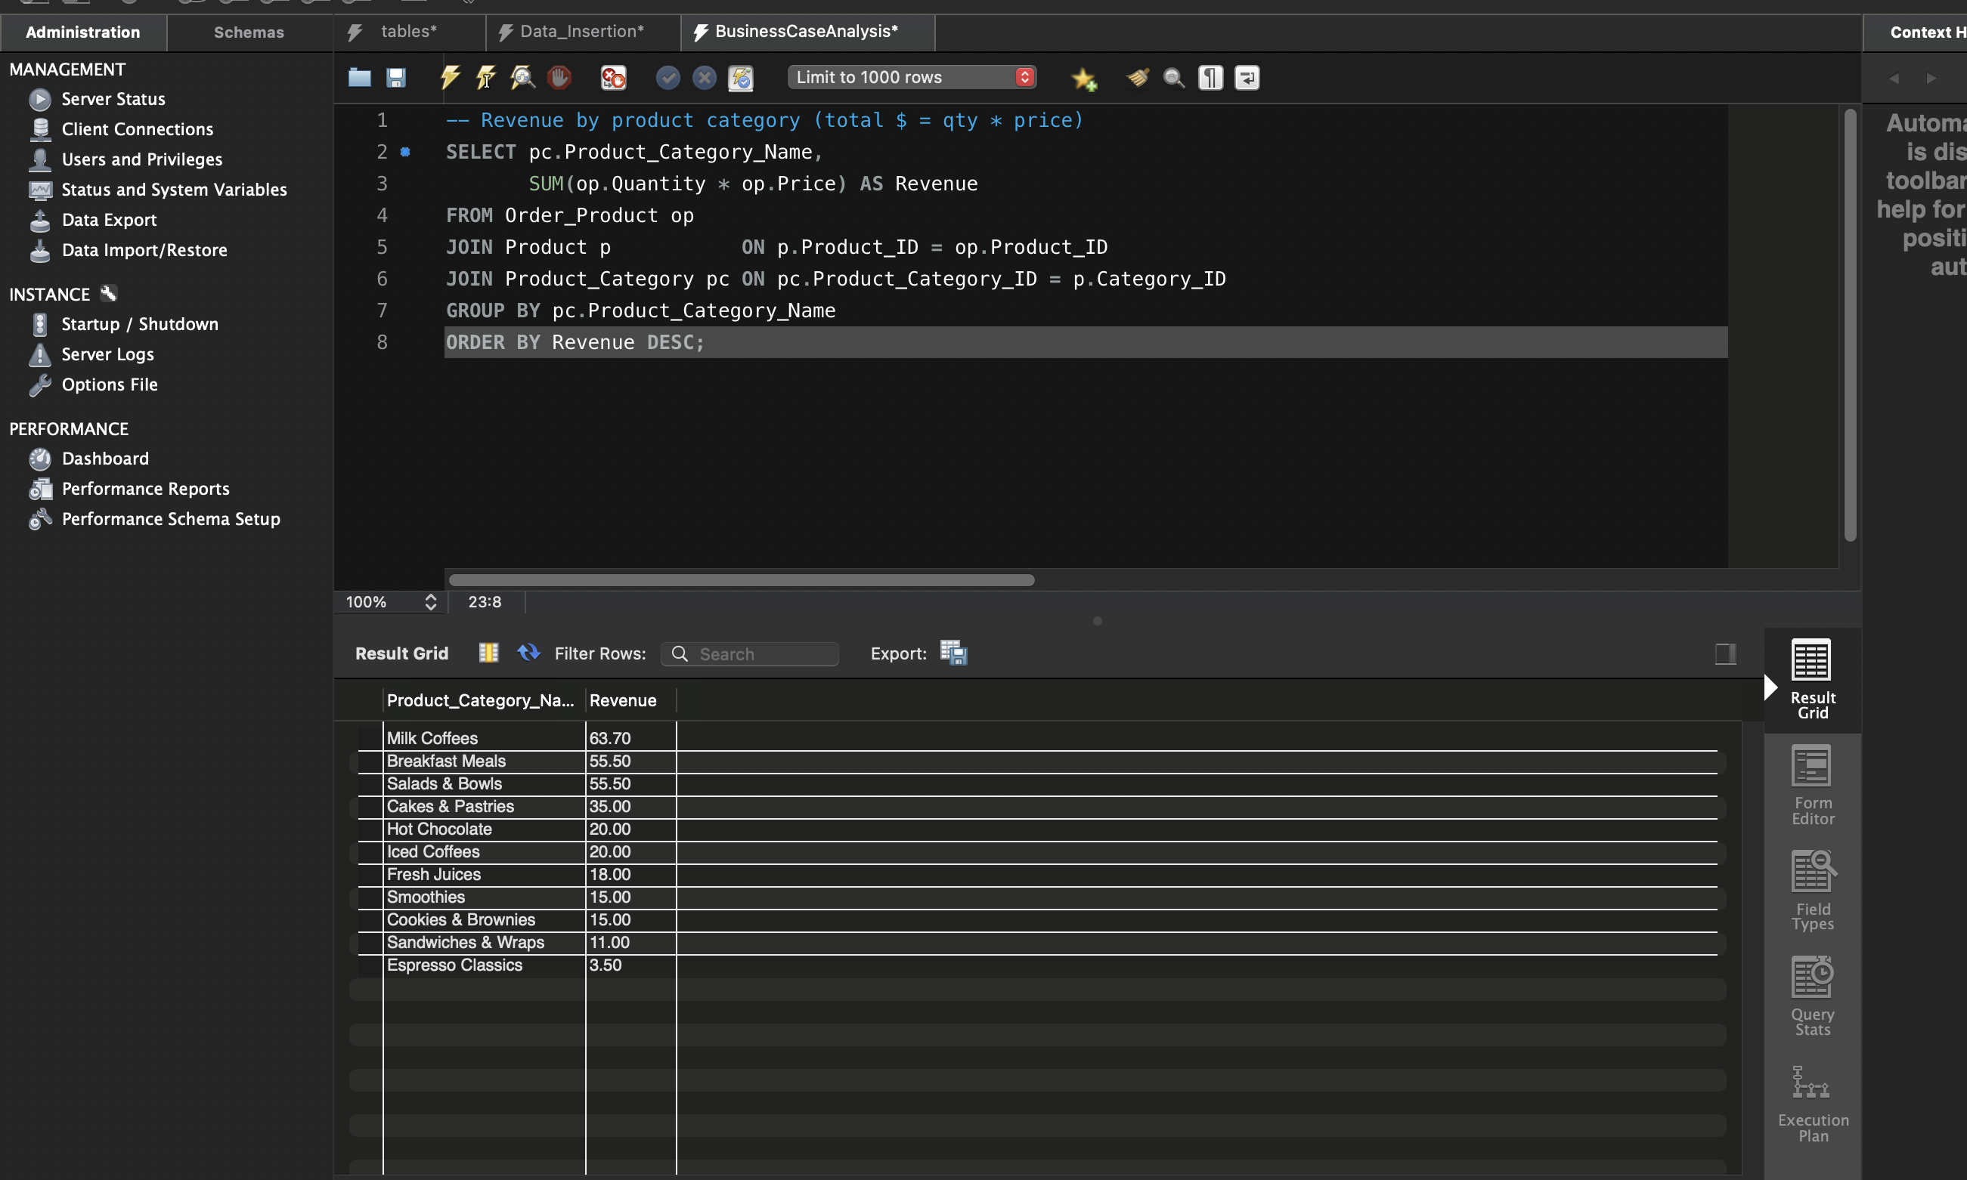

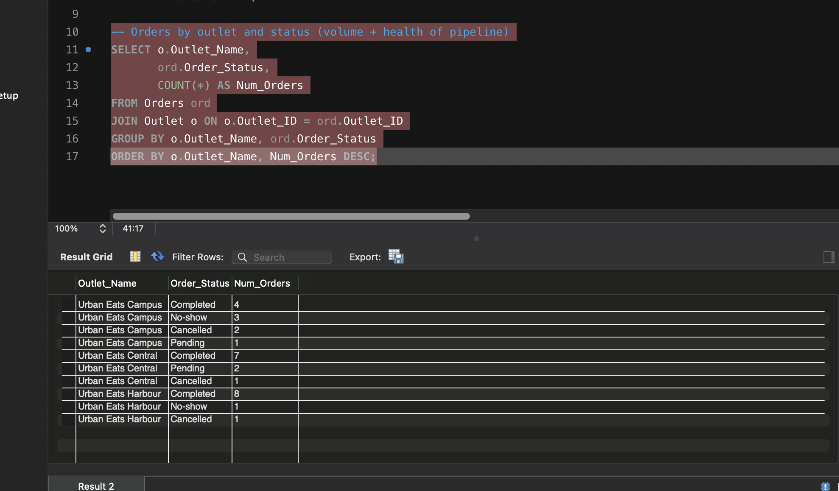

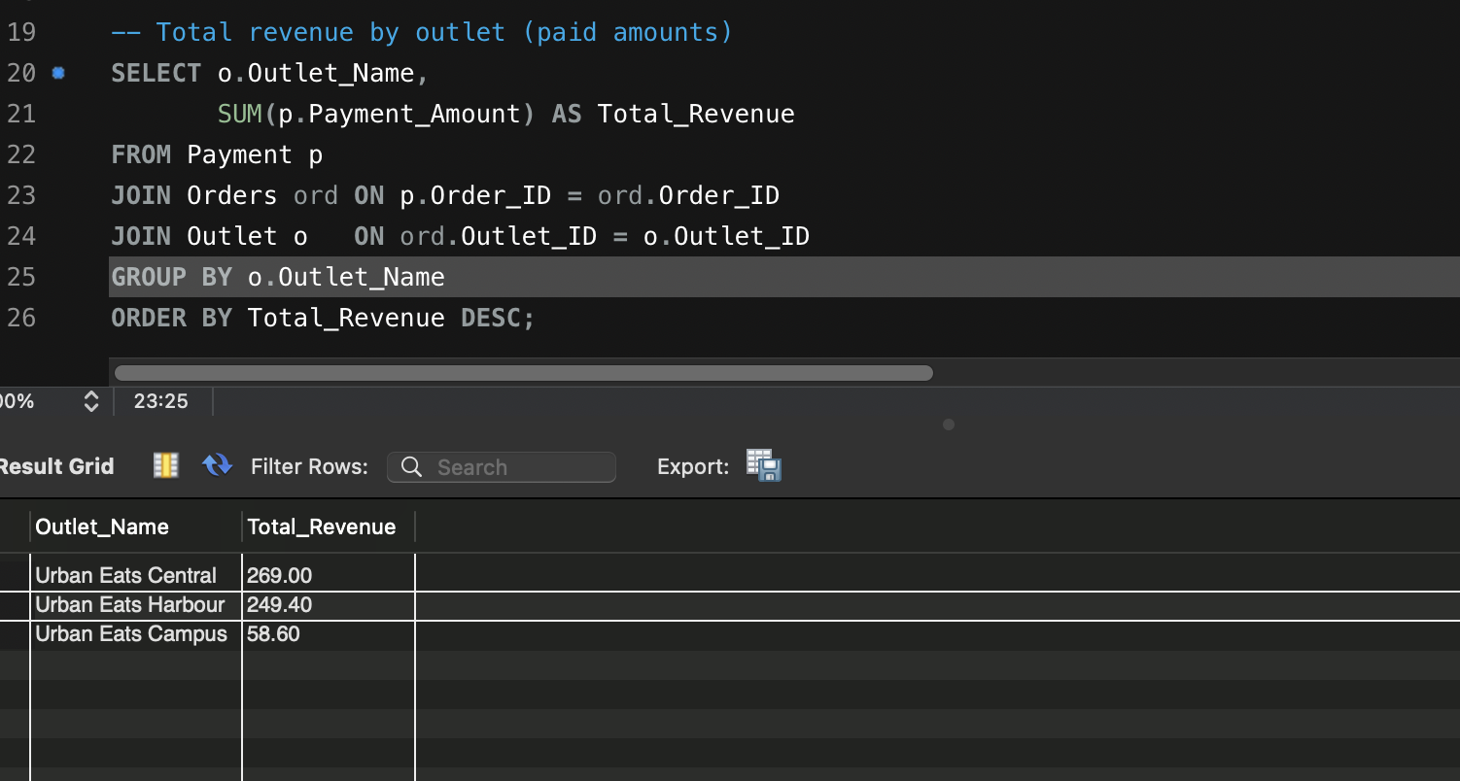

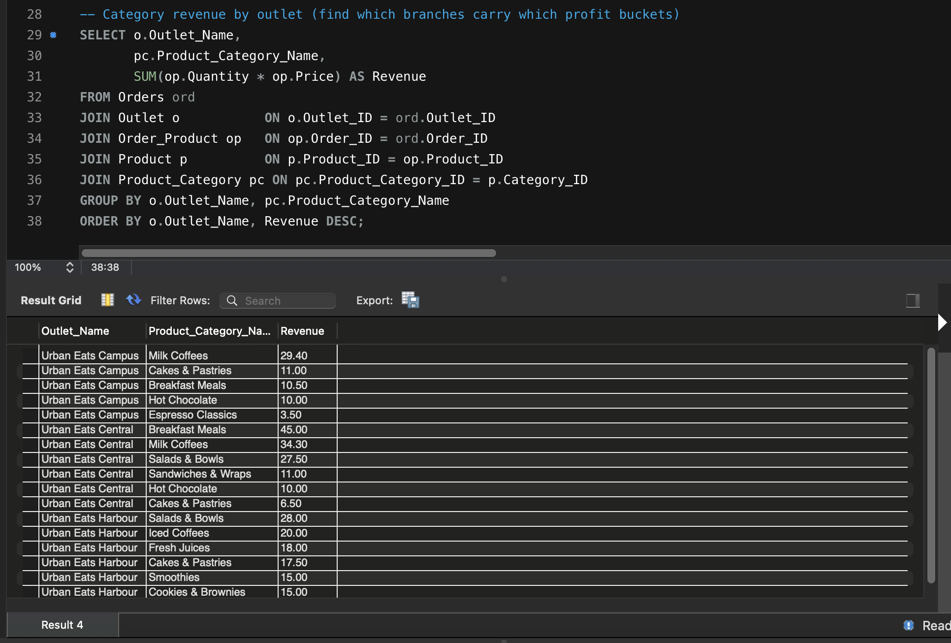

**Justification and Insights**

Central is the most profitable outlet with a balanced category mix, sustaining consistent revenue streams across beverages, meals, and desserts. Harbour thrives on its cold-drink and dessert niche, performing strongly despite limited high-margin meal offerings. Campus faces severe profitability challenges, generating only a fraction of the revenue of other outlets due to cancellations, no-shows, and restricted product variety. Espresso Classics should be reviewed for either rebranding or removal, as they show minimal contribution. Strategic actions include expanding meal offerings at Campus to capture higher ticket sales, strengthening operational control over reservations to reduce no-shows, and rebalancing marketing focus to promote underperforming but high-margin categories.

## Business concern 2 Customer Retention

**Name and Description:** The goal is to assess which customers show loyalty through repeat purchases, which are at risk of churn, and how reservation behaviour signals long-term retention. By linking order frequency, payment status, and reservation completion, we can identify profitable repeaters versus high-risk one-time or failed customers.

**SQL Query**

-- Customers loyal to a category (2+ orders in same category)

SELECT c.Customer_ID,

c.First_Name,

c.Last_Name,

pc.Product_Category_Name,

COUNT(*) AS Orders_In_Category

FROM Orders o

JOIN Order_Product op ON op.Order_ID = o.Order_ID

JOIN Product p ON p.Product_ID = op.Product_ID

JOIN Product_Category pc ON pc.Product_Category_ID = p.Category_ID

JOIN Customer c ON c.Customer_ID = o.Customer_ID

GROUP BY c.Customer_ID, c.First_Name, c.Last_Name, pc.Product_Category_Name

HAVING COUNT(*) >= 2

ORDER BY Orders_In_Category DESC;

-- Loyal vs one-timer by outlet (customer order counts per outlet)

SELECT o.Outlet_Name,

c.Customer_ID,

c.First_Name,

c.Last_Name,

COUNT(*) AS Orders_At_Outlet,

CASE WHEN COUNT(*) >= 2 THEN 'Loyal' ELSE 'One-timer' END AS Segment

FROM Orders ord

JOIN Outlet o ON o.Outlet_ID = ord.Outlet_ID

JOIN Customer c ON c.Customer_ID = ord.Customer_ID

GROUP BY o.Outlet_Name, c.Customer_ID, c.First_Name, c.Last_Name

ORDER BY o.Outlet_Name, Orders_At_Outlet DESC;

-- Failed / no-show signals tied to churn risk

SELECT c.Customer_ID,

c.First_Name,

c.Last_Name,

ord.Order_ID,

COALESCE(p.Payment_Status, 'No Payment') AS Payment_Status,

ord.Order_Status

FROM Orders ord

LEFT JOIN Payment p ON p.Order_ID = ord.Order_ID

JOIN Customer c ON c.Customer_ID = ord.Customer_ID

WHERE COALESCE(p.Payment_Status, 'No Payment') IN ('Failed','Refunded','Pending','No Payment')

OR ord.Order_Status IN ('Cancelled','No-show')

ORDER BY c.Customer_ID, ord.Order_ID;

-- Reservation - order conversion rate by outlet (loyalty signal)

-- Assumes Reservation has Customer_ID and an Order can be linked via Customer + date window or a Reservation_ID if present.

SELECT o.Outlet_Name,

SUM(CASE WHEN r.Status = 'Completed' THEN 1 ELSE 0 END) AS Reservations_Completed,

SUM(CASE WHEN r.Status IN ('No-show','Cancelled') THEN 1 ELSE 0 END) AS Reservations_Failed,

COUNT(*) AS Reservations_Total,

ROUND(100.0 * SUM(CASE WHEN r.Status='Completed' THEN 1 ELSE 0 END)

/ NULLIF(COUNT(*),0), 1) AS Reservation_Completion_Pct

FROM Reservation r

JOIN Outlet o ON o.Outlet_ID = r.Outlet_ID

GROUP BY o.Outlet_Name

ORDER BY Reservation_Completion_Pct DESC;

**SQL Result**

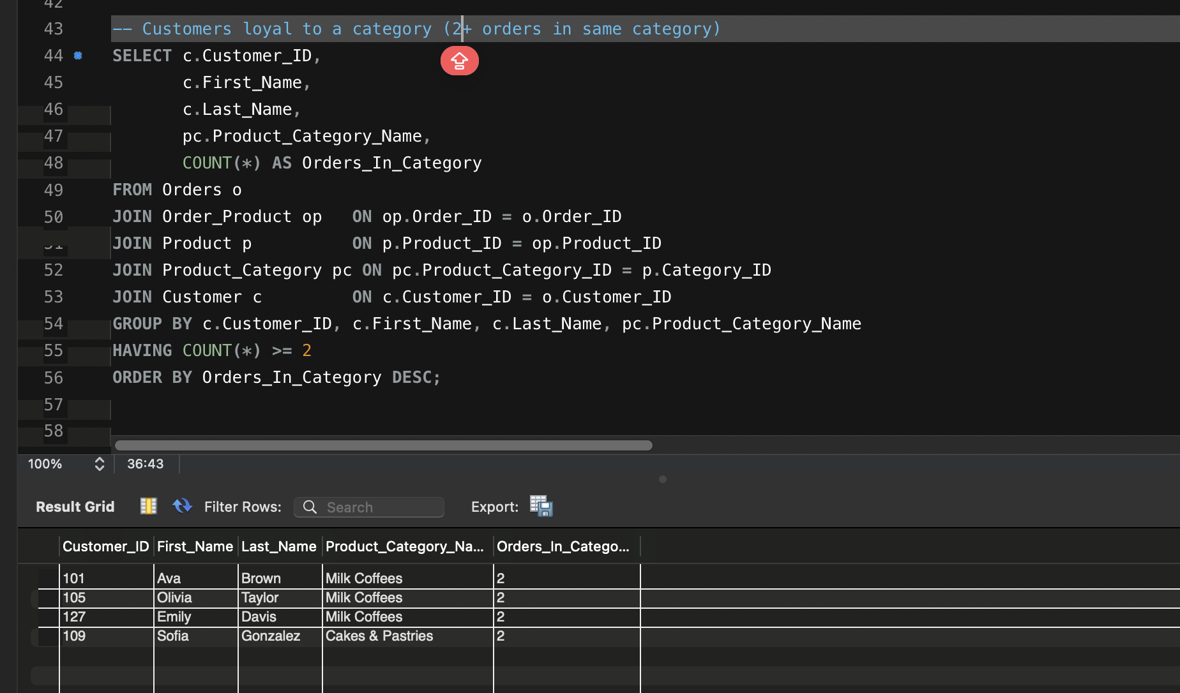

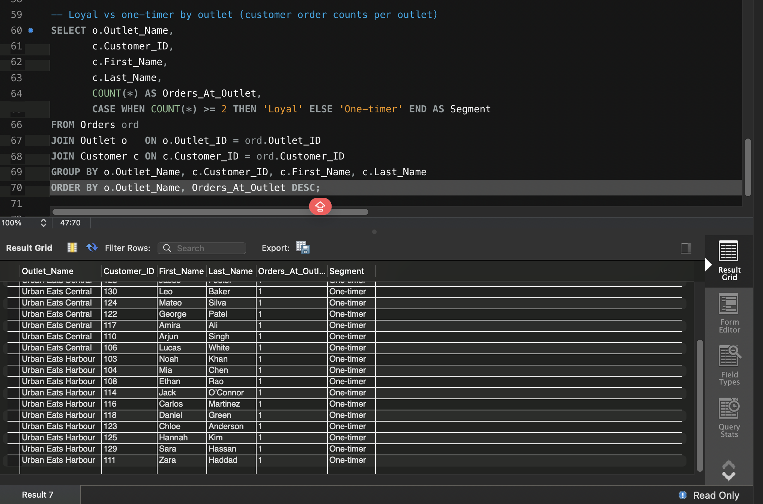

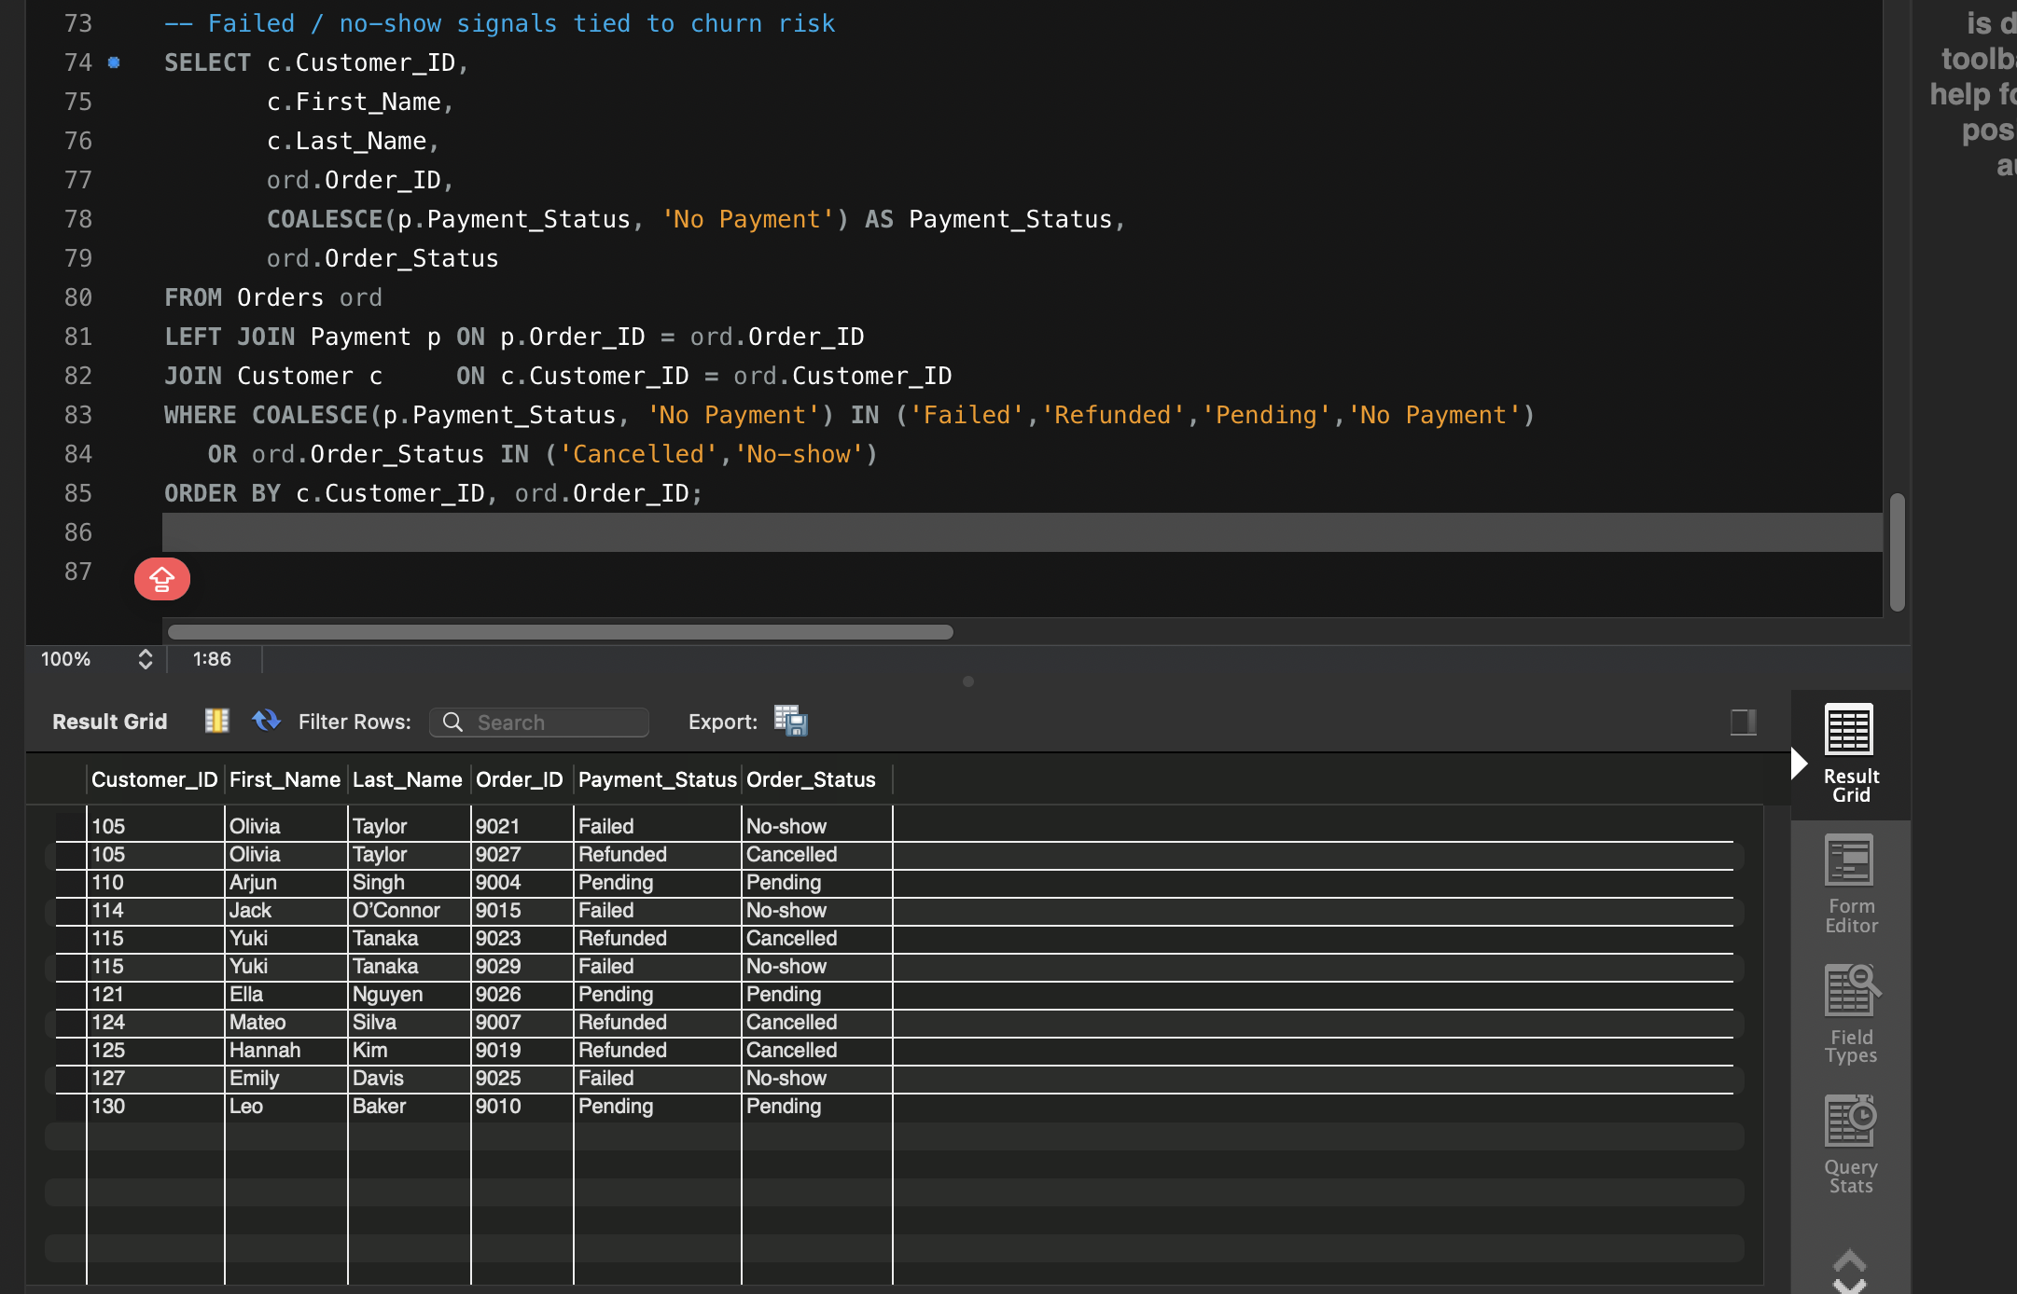

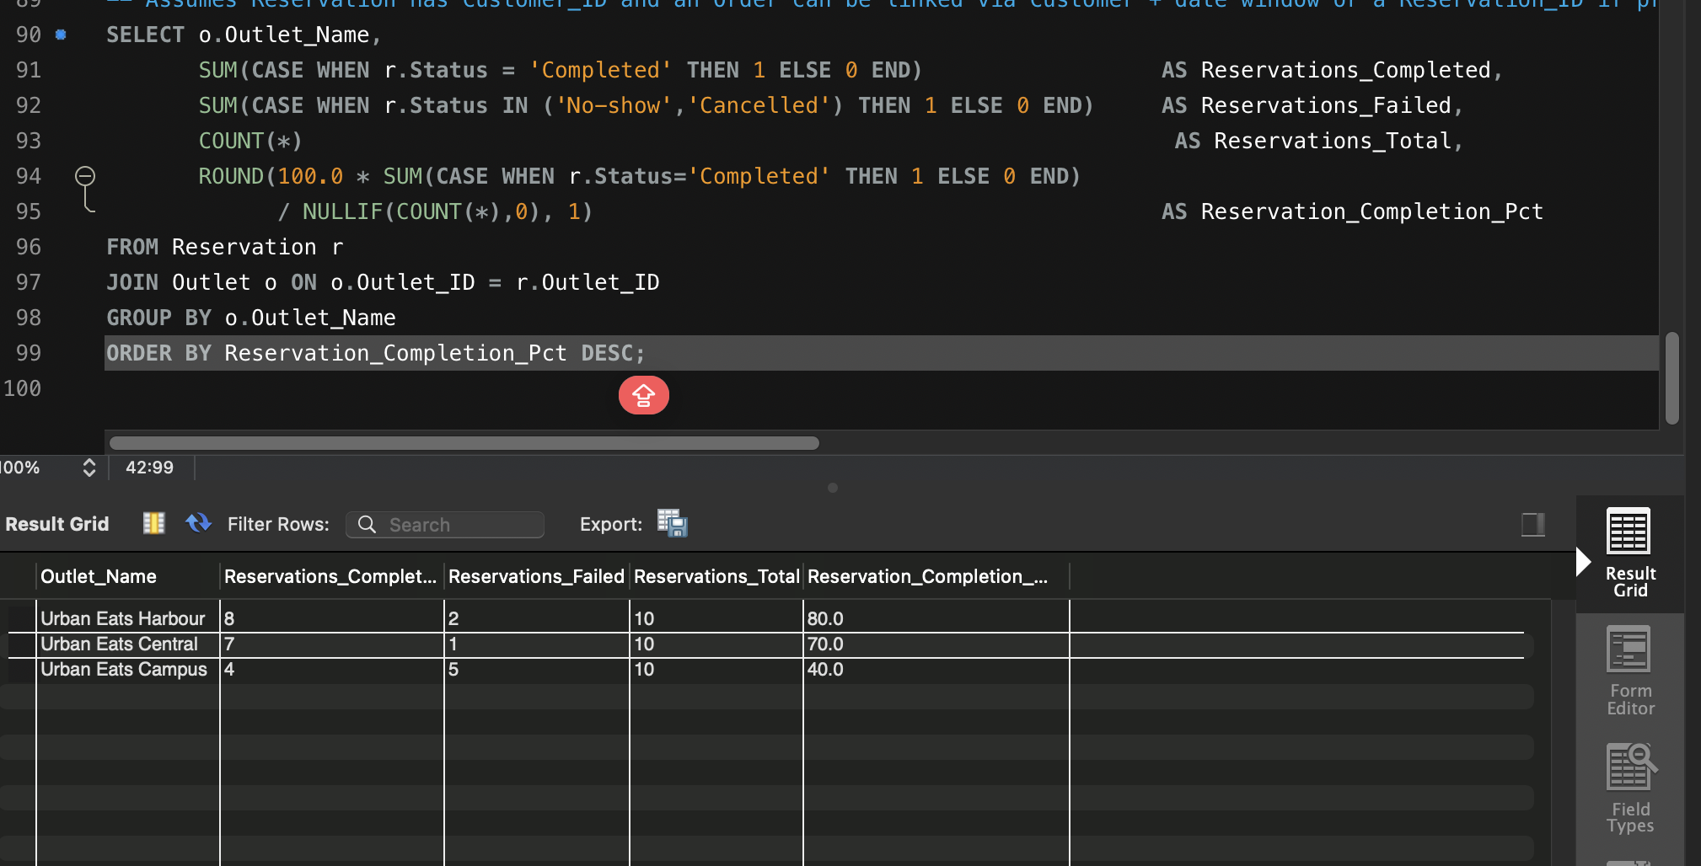

**Justification and Insights**

Loyalty exists but is fragile, with most customers concentrated in a single product category. Failed or refunded payments directly overlap with no-shows, amplifying churn risk. Harbour performs best in converting reservations to actual orders, while Campus demonstrates severe reliability issues, damaging long-term retention. Strategic actions include building loyalty incentives for category-driven customers such as beverage and dessert bundles, strengthening payment and reservation enforcement to reduce attrition, and focusing on Campus process improvements through confirmation systems and a deposit policy to boost conversion rates and retain customers.

## Business concern 3 Menu Optimisation

**Name and Description:** This analysis identifies which product categories and individual menu items are underperforming, and how sales distribution varies by outlet. The objective is to optimise the menu by pruning weak items, promoting consistent performers, and aligning product availability with outlet demand.

**SQL Query**

-- Underperforming categories (low order count)

SELECT pc.Product_Category_Name,

COUNT(*) AS Times_Ordered

FROM Order_Product op

JOIN Product p ON p.Product_ID = op.Product_ID

JOIN Product_Category pc ON pc.Product_Category_ID = p.Category_ID

GROUP BY pc.Product_Category_Name

ORDER BY Times_Ordered ASC;

-- Underperforming products (identify items to prune)

SELECT p.Product_Name,

COUNT(*) AS Times_Ordered

FROM Order_Product op

JOIN Product p ON p.Product_ID = op.Product_ID

GROUP BY p.Product_Name

ORDER BY Times_Ordered ASC, p.Product_Name;

-- Product sales by outlet (see where each item actually sells)

SELECT o.Outlet_Name,

p.Product_Name,

SUM(op.Quantity) AS Units_Sold,

SUM(op.Quantity * op.Price) AS Revenue

FROM Orders ord

JOIN Outlet o ON o.Outlet_ID = ord.Outlet_ID

JOIN Order_Product op ON op.Order_ID = ord.Order_ID

JOIN Product p ON p.Product_ID = op.Product_ID

GROUP BY o.Outlet_Name, p.Product_Name

ORDER BY o.Outlet_Name, Revenue DESC;

**SQL Result**

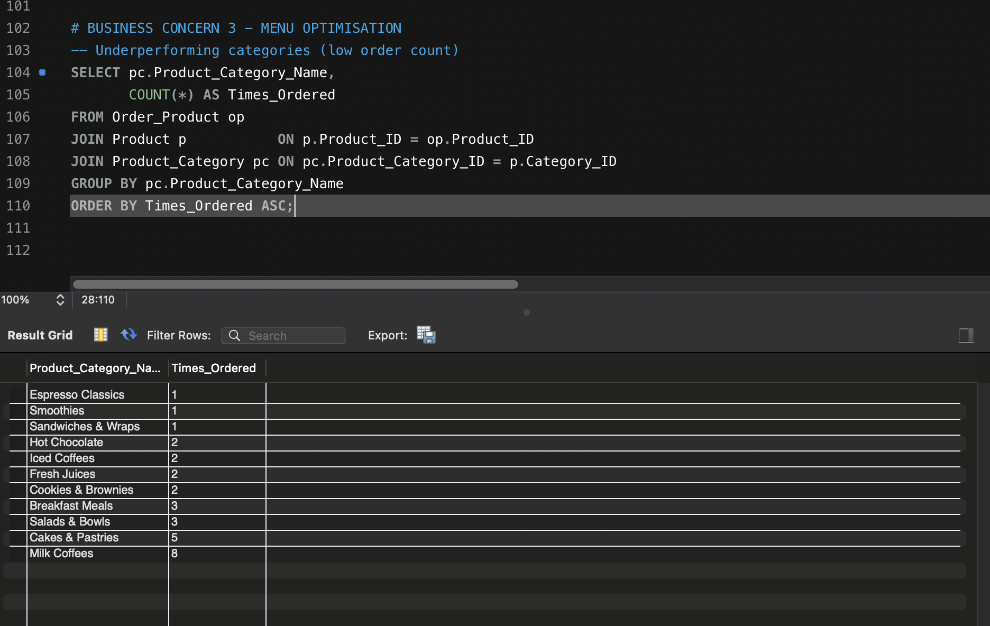

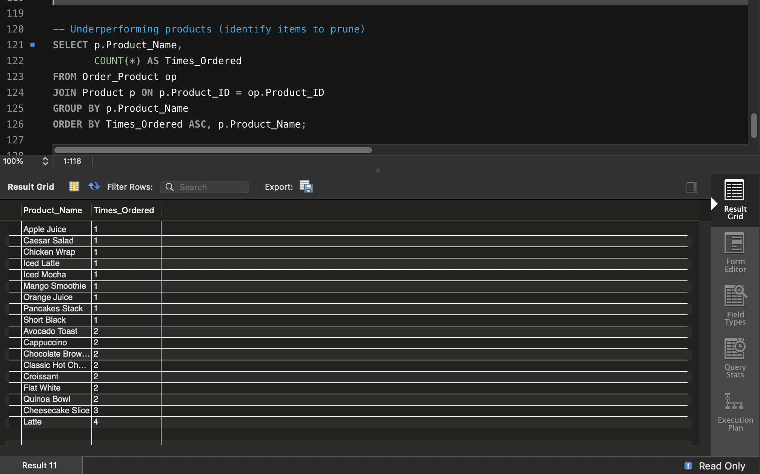

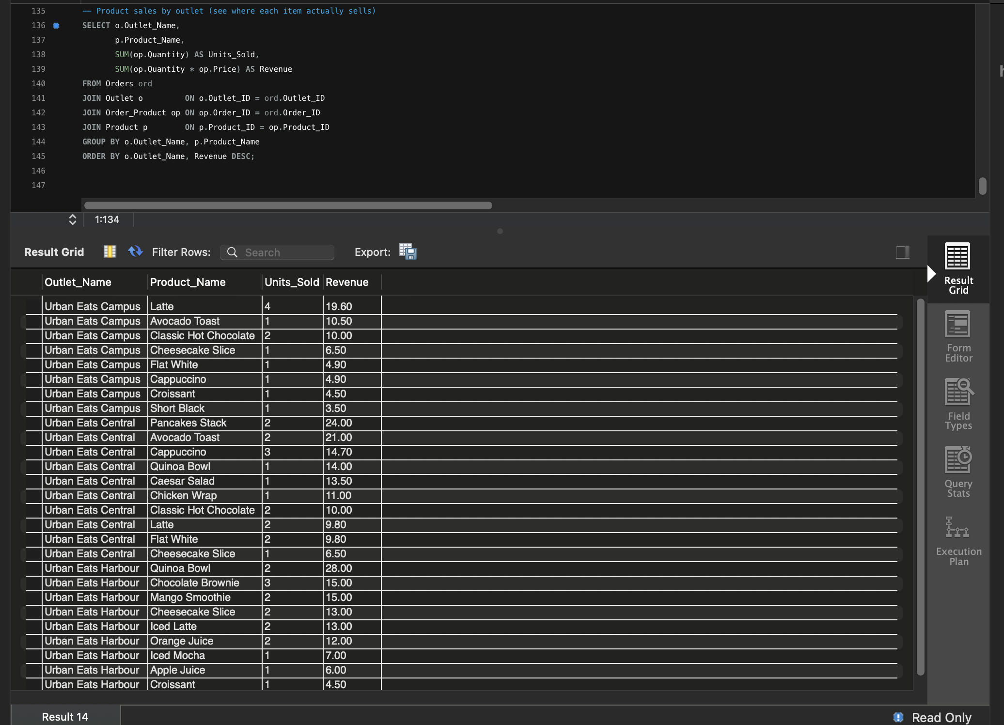

**Justification and Insights**

Menu has too many low-performing items with negligible demand, increasing operational costs without contributing to revenue. Campus outlet lacks diversity and relies heavily on a few products, limiting its ability to capture customer preferences. Harbour validates its tourist strategy with cold beverages and desserts driving revenue, but offers little in high-margin meals. Central is the most balanced outlet with both meals and beverages performing well. Strategic actions include pruning or rebranding consistently underperforming items such as Espresso Classics, Apple Juice, and Caesar Salad, focusing promotions on mid-tier items like Quinoa Bowls and Cappuccino that have potential but limited current traction, and reallocating menu design so that Central retains full diversity, Harbour doubles down on drinks and desserts, and Campus expands to include more meal options.

## Business concern 4 Staff Scheduling and Performance

**Name and Description:** This analysis examines whether staff allocation is aligned with demand across outlets and shifts. It looks at utilisation rates, the ratio of active staff to total staff, and the distribution of product demand by role groups (barista, chef, server/baker). The aim is to identify inefficiencies, understaffing risks, and role mismatches that directly affect service quality and revenue.

**SQL Query**

-- Shift utilisation: how full were shifts staffed vs Max_Staff

SELECT s.Shift_ID,

s.Outlet_ID,

s.Max_Staff,

COUNT(ss.Staff_ID) AS Assigned,

ROUND(100.0 * COUNT(ss.Staff_ID) / NULLIF(s.Max_Staff,0), 1) AS Utilisation_Pct

FROM Shift s

LEFT JOIN Staff_Shift ss ON ss.Shift_ID = s.Shift_ID

GROUP BY s.Shift_ID, s.Outlet_ID, s.Max_Staff

ORDER BY Utilisation_Pct ASC;

-- Active vs total staff by outlet (capacity view)

SELECT o.Outlet_Name,

COUNT(*) AS Total_Staff,

SUM(CASE WHEN s.Employment_Status='Active' THEN 1 ELSE 0 END) AS Active_Staff

FROM Staff s

JOIN Outlet o ON s.Outlet_ID = o.Outlet_ID

GROUP BY o.Outlet_Name

ORDER BY Active_Staff DESC;

-- Active vs total staff by outlet (capacity view)

SELECT o.Outlet_Name,

COUNT(*) AS Total_Staff,

SUM(CASE WHEN s.Employment_Status='Active' THEN 1 ELSE 0 END) AS Active_Staff

FROM Staff s

JOIN Outlet o ON s.Outlet_ID = o.Outlet_ID

GROUP BY o.Outlet_Name

ORDER BY Active_Staff DESC;

-- Category skills vs outlet demand (barista vs chef vs baker)

-- Map category groups to roles for mismatch checks.

SELECT o.Outlet_Name,

CASE

WHEN pc.Product_Category_Name IN ('Espresso Classics','Milk Coffees','Iced Coffees','Cold Drinks','Smoothies','Juices') THEN 'Barista'

WHEN pc.Product_Category_Name IN ('Breakfast','Bowls & Salads','Meals') THEN 'Chef'

WHEN pc.Product_Category_Name IN ('Cakes & Pastries','Cookies & Desserts') THEN 'Server/Baker'

ELSE 'Other'

END AS Role_Group,

SUM(op.Quantity) AS Units_Sold

FROM Orders ord

JOIN Outlet o ON o.Outlet_ID = ord.Outlet_ID

JOIN Order_Product op ON op.Order_ID = ord.Order_ID

JOIN Product p ON p.Product_ID = op.Product_ID

JOIN Product_Category pc ON pc.Product_Category_ID = p.Category_ID

GROUP BY o.Outlet_Name, Role_Group

ORDER BY o.Outlet_Name, Units_Sold DESC;

**SQL Result**

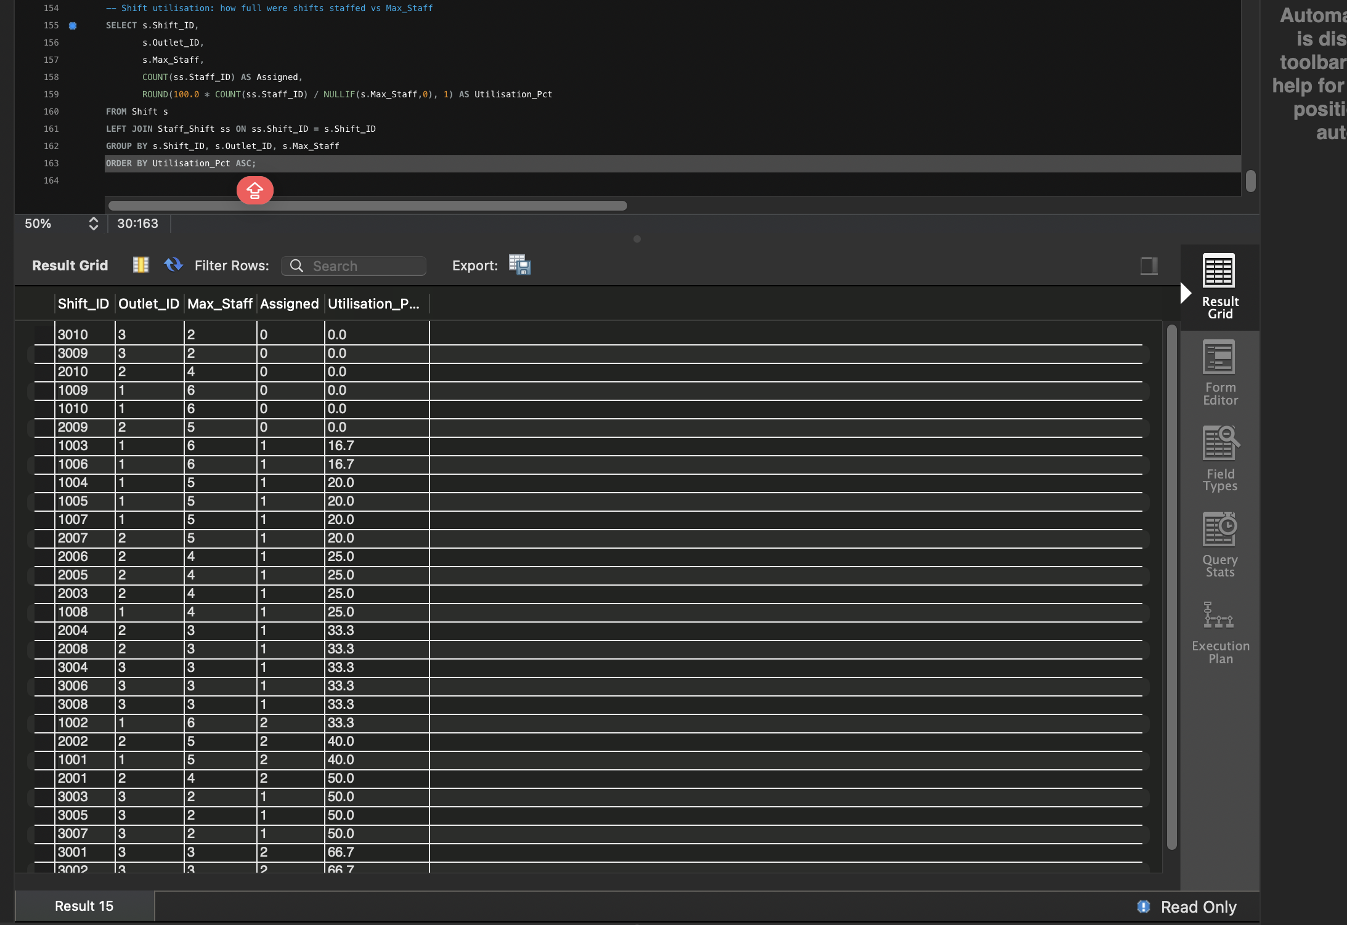

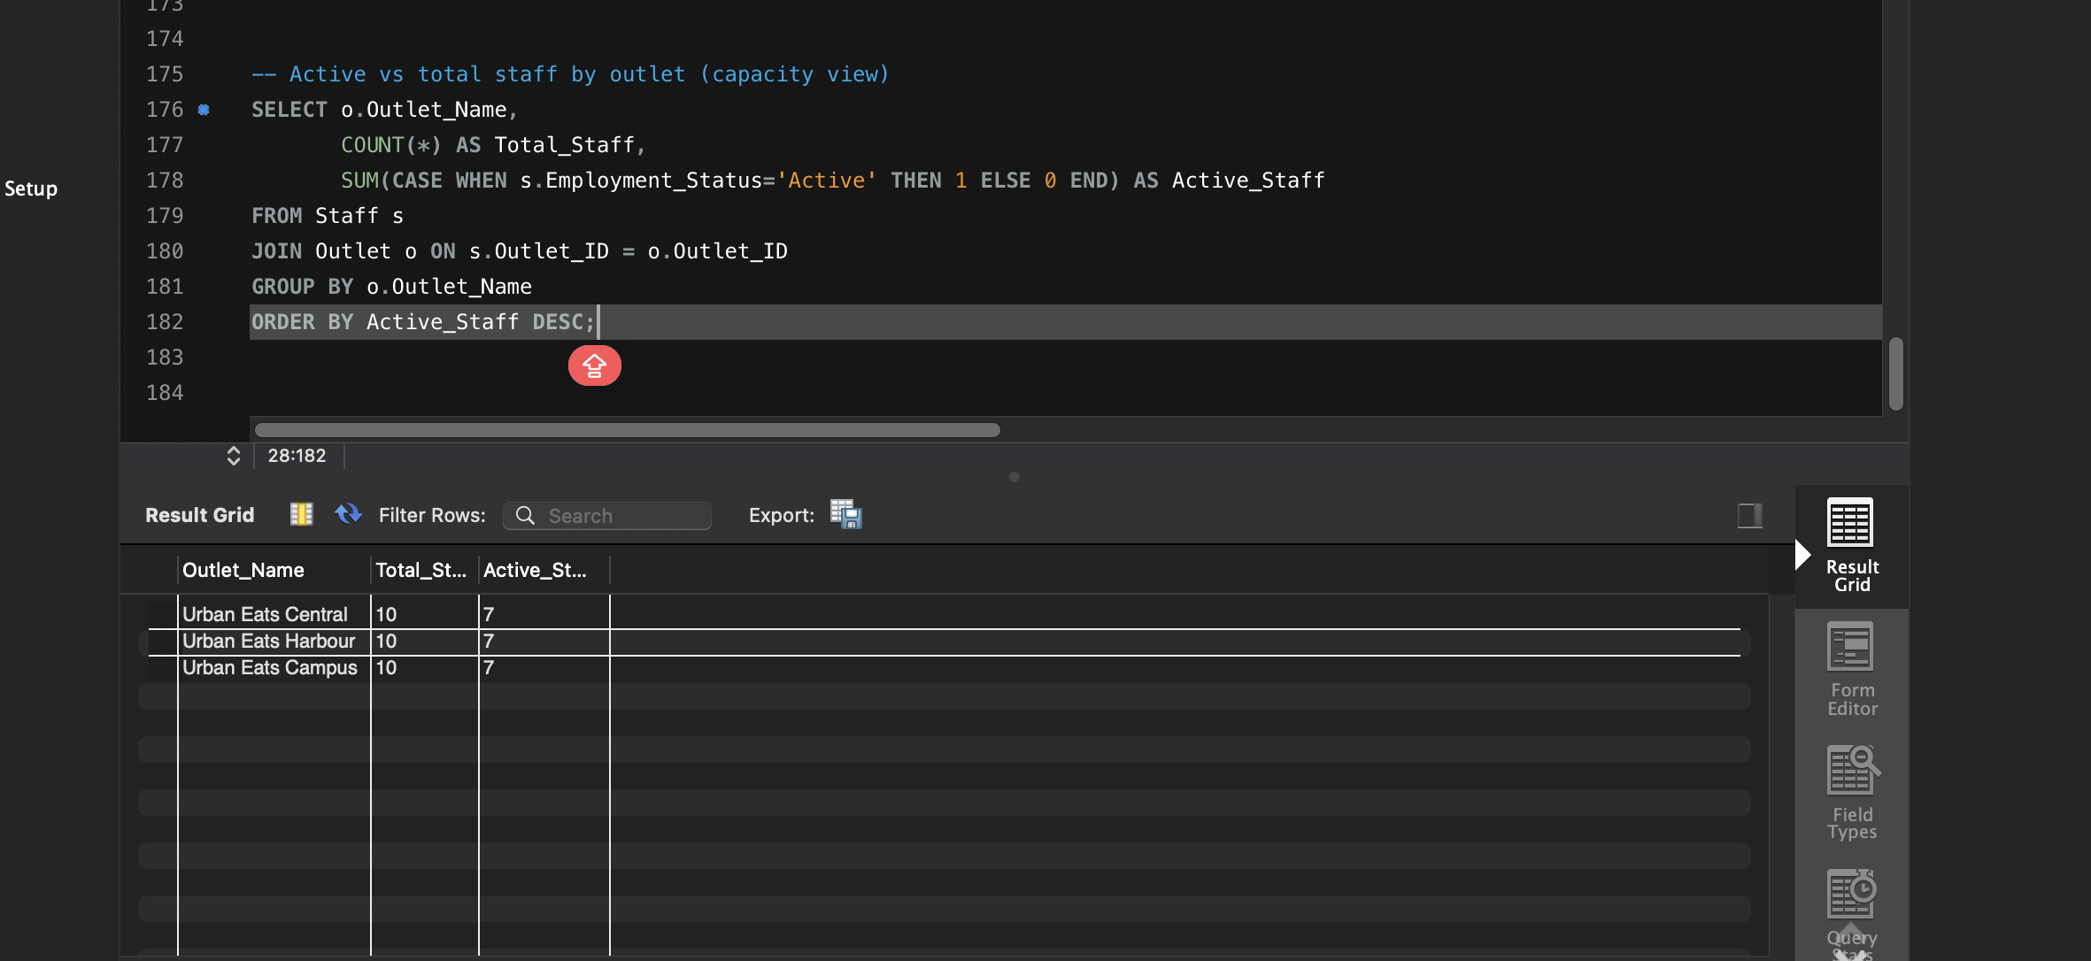

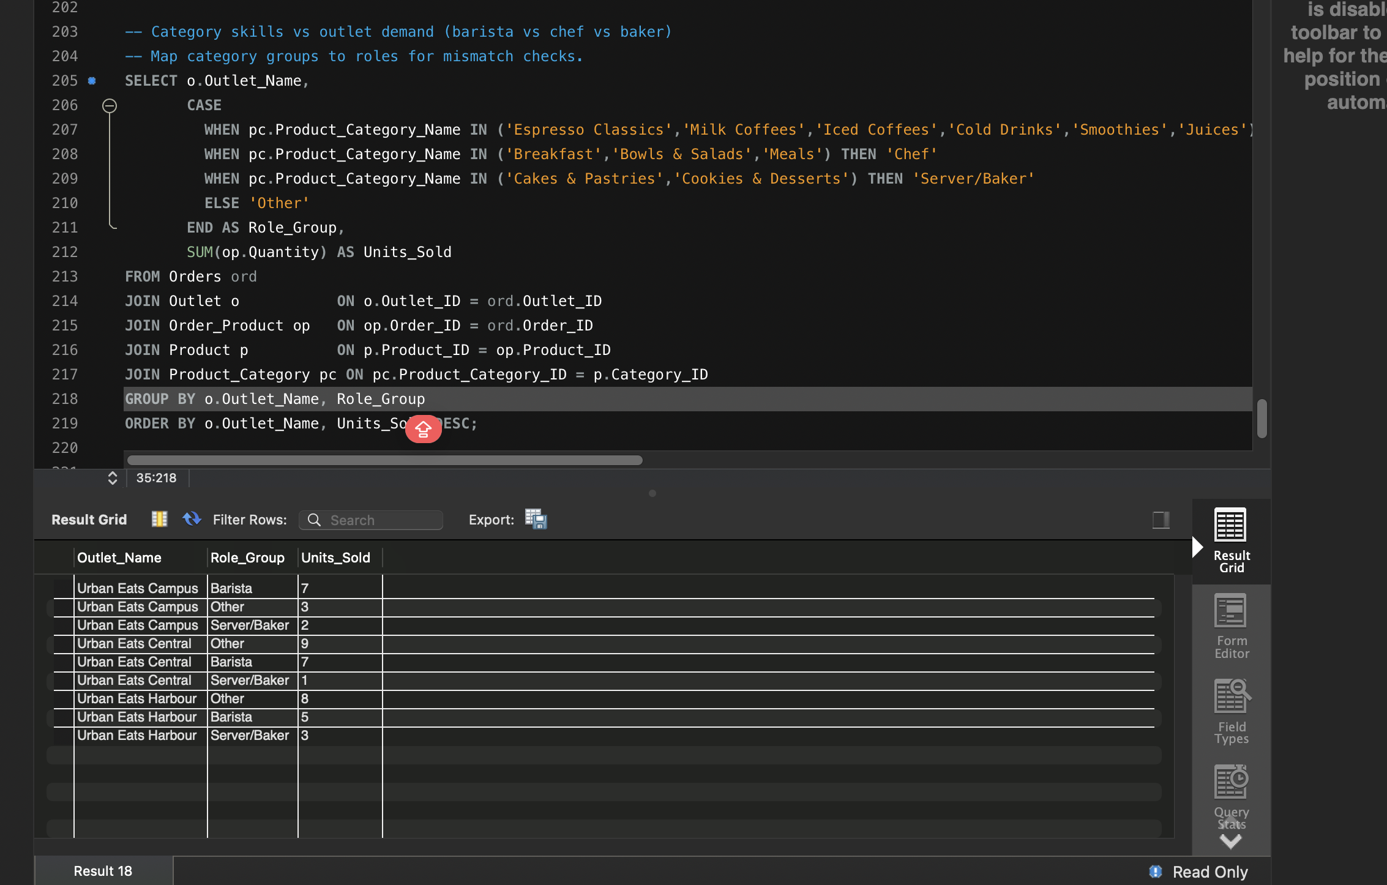

**Justification and Insights**

Central shows strong, balanced role demand, but needs careful scheduling to ensure chef and barista coverage, with occasional underutilisation indicating potential overstaffing in certain shifts. Harbour demand is dominated by barista-driven categories such as cold drinks and coffees, aligning with its tourist-driven menu, and lower chef demand validates reduced chef staffing here. Campus faces severely under-utilised staff allocation with several shifts left unstaffed, leading to poor service reliability and an inability to capture revenue; Campus is also beverage-heavy, requiring primarily baristas and minimal chef input. Strategic actions include improving shift planning at Campus to eliminate 0% utilisation shifts and match staff presence with demand, optimising role allocation by outlet so that Central maintains balanced coverage across roles, Harbour focuses on baristas and servers while limiting chefs, and Campus scales down chefs while focusing on baristas, and exploring cross-training staff to cover gaps during under-staffed shifts to ensure resilience.

## Business concern 5 Branch Level Operational Efficiency

**Name and Description:** This concern evaluates how effectively each outlet manages product availability, reservation reliability, and the end-to-end order-to-payment flow. By comparing availability breadth, reservation conversion, and revenue outcomes, we can pinpoint where operational gaps are reducing outlet performance.

**SQL Query**

-- Available vs Unavailable products per outlet (menu breadth)

SELECT o.Outlet_Name,

op.Outlet_Status,

COUNT(*) AS Product_Count

FROM Outlet_Product op

JOIN Outlet o ON op.Outlet_ID = o.Outlet_ID

GROUP BY o.Outlet_Name, op.Outlet_Status

ORDER BY o.Outlet_Name, op.Outlet_Status;

-- Count of AVAILABLE products by outlet (quick capacity proxy)

SELECT o.Outlet_Name,

COUNT(*) AS Available_Products

FROM Outlet_Product op

JOIN Outlet o ON op.Outlet_ID = o.Outlet_ID

WHERE op.Outlet_Status = 'Available'

GROUP BY o.Outlet_Name

ORDER BY Available_Products DESC;

-- Reservation conversion quality by outlet (service reliability)

SELECT o.Outlet_Name,

r.Status,

COUNT(*) AS Cnt

FROM Reservation r

JOIN Outlet o ON r.Outlet_ID = o.Outlet_ID

GROUP BY o.Outlet_Name, r.Status

ORDER BY o.Outlet_Name, Cnt DESC;

-- Orders and payments by outlet (end-to-end flow)

SELECT o.Outlet_Name,

COUNT(DISTINCT ord.Order_ID) AS Total_Orders,

SUM(CASE WHEN ord.Order_Status='Completed' THEN 1 ELSE 0 END) AS Completed_Orders,

SUM(p.Payment_Amount) AS Total_Revenue

FROM Orders ord

LEFT JOIN Payment p ON p.Order_ID = ord.Order_ID

JOIN Outlet o ON o.Outlet_ID = ord.Outlet_ID

GROUP BY o.Outlet_Name

ORDER BY Total_Revenue DESC;

**SQL Result**

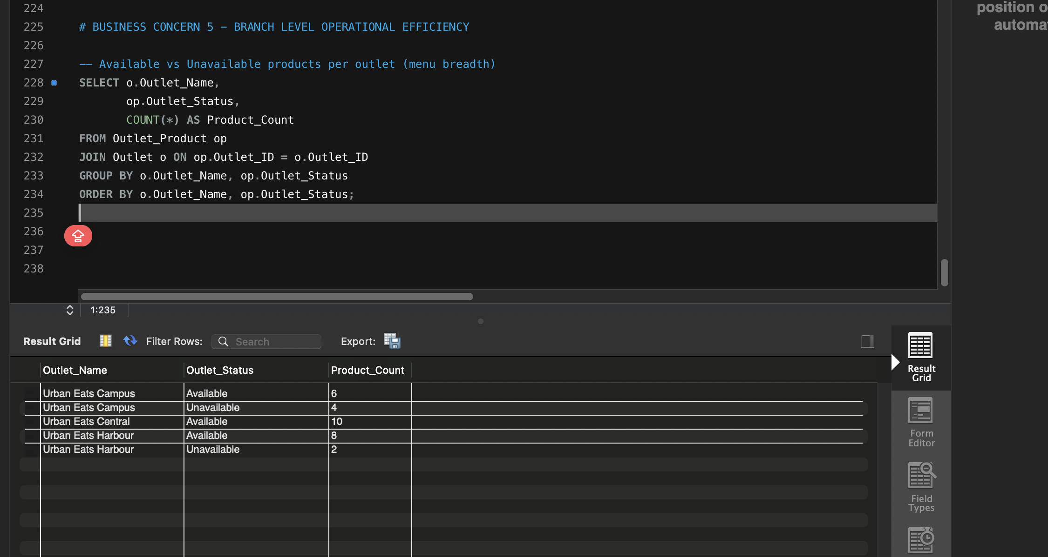

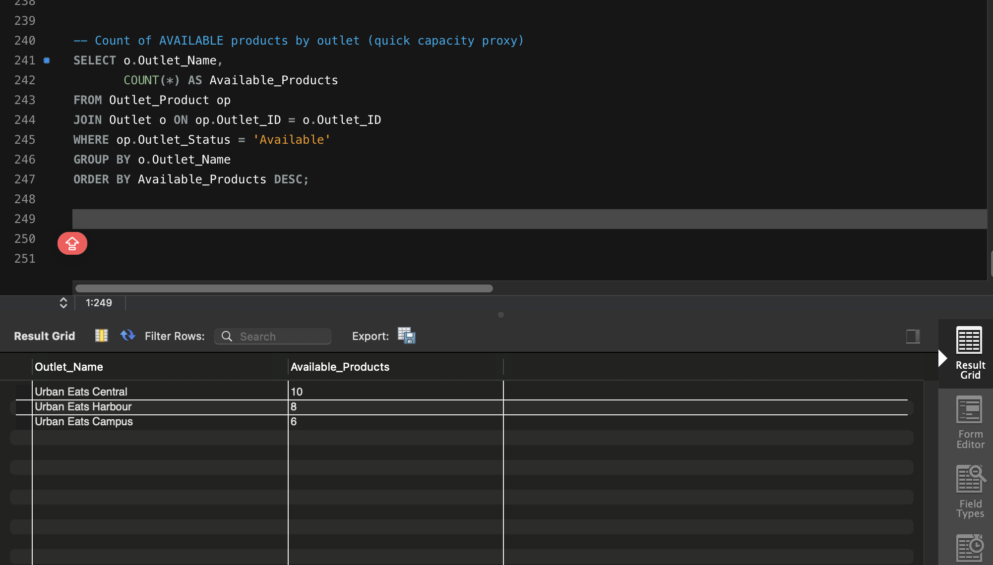

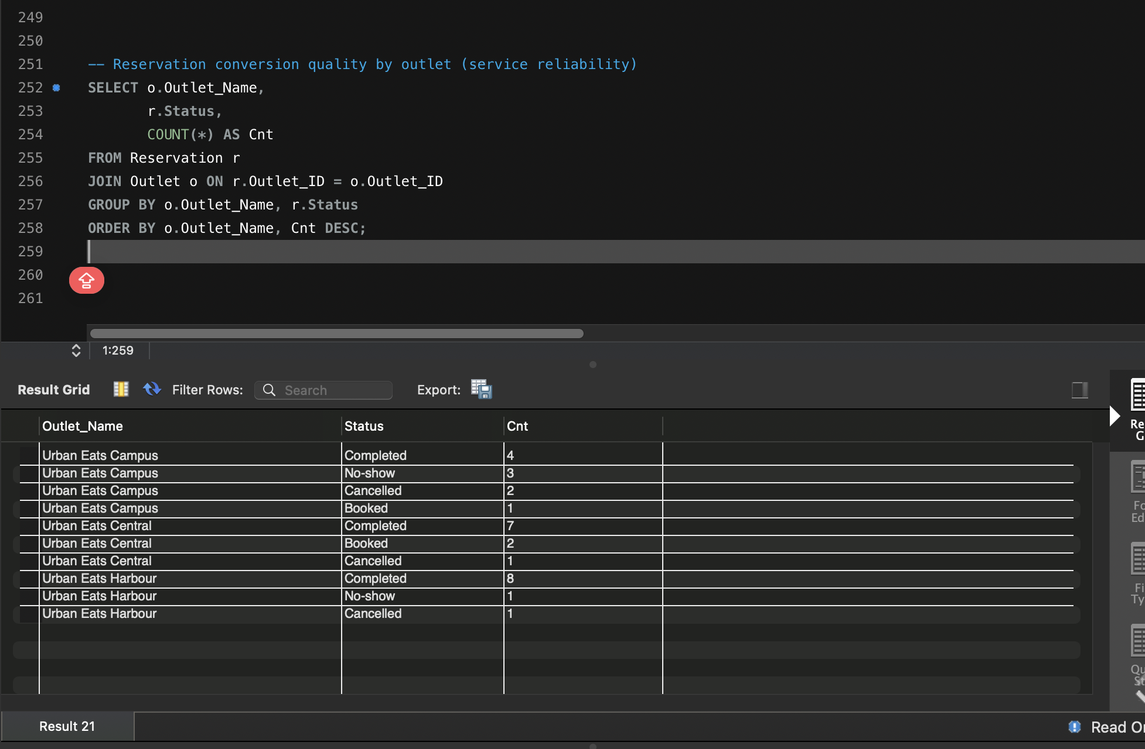

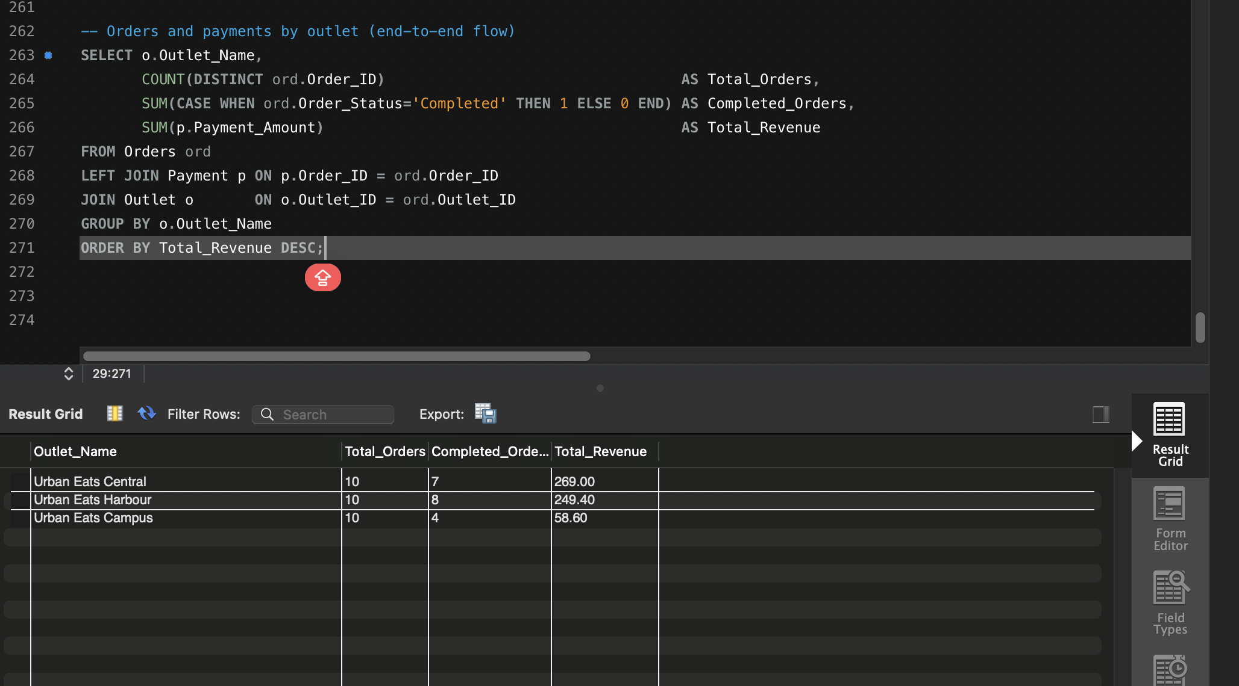

**Justification and Insights**

Urban Eats Central is the strongest performer overall, with maximum menu breadth, high reservation reliability, and top revenue, showing that operational efficiency is aligned across availability and customer conversion. Urban Eats Harbour performs well despite slightly fewer products, benefiting from strong reservation conversion and demand for niche cold-drink and dessert items. Urban Eats Campus, however, is a major bottleneck with limited product availability, high cancellation and no-show rates, and the lowest revenue despite similar order inflow, which indicates that Campus suffers from poor execution rather than a shortage of demand. Strategic actions include expanding the available menu at Campus, enforcing stricter reservation and payment controls, and stabilising service reliability. Harbour should maintain its current strengths while improving stock consistency to match Central’s product breadth, while Central should continue optimising as the operational benchmark and potentially serve as a best-practice model for Campus recovery.

## Conclusion

Urban Eats demonstrates clear differences across its three outlets. Central consistently stands out as the most profitable and operationally balanced branch, offering a diverse menu, reliable reservations, and well-distributed staff roles, making it the benchmark for best practices. Harbour thrives in its niche of cold drinks and desserts, converting reservations effectively and leveraging its tourist-driven strategy, though its reliance on limited high-margin meals presents a growth challenge. Campus, in contrast, struggles with profitability due to high no-shows, cancellations, restricted product variety, and poor staff allocation, highlighting execution issues rather than demand shortages. Across outlets, menu optimisation is necessary to address low-performing items, while customer retention remains fragile due to loyalty concentrated in single categories and payment failures linked to no-shows. Strategic focus should therefore centre on expanding meal offerings and process improvements at Campus, building loyalty incentives, refining staff scheduling, and pruning underperforming menu items. By reinforcing Central as the model of efficiency, Harbour as a niche-driven outlet, and Campus as the priority for operational recovery, Urban Eats can achieve stronger overall performance and sustainable growth.